|  |
| --- |
|  |
| Documentation |
| SMOC |
|  |

**Accounts**

**Masters**

Define Financial Year:

Screen Shot:

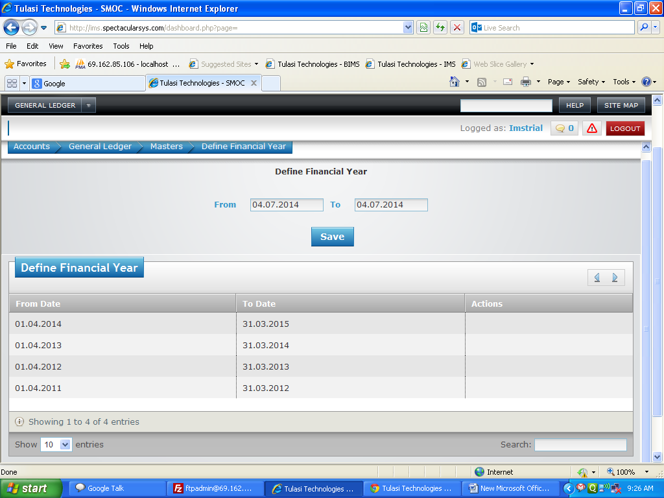

Basic Functionality:

1. This form is used to define the financial year.

Effecting Tables:

* ac_definefy.

Define Schedule:

Screen Shot:

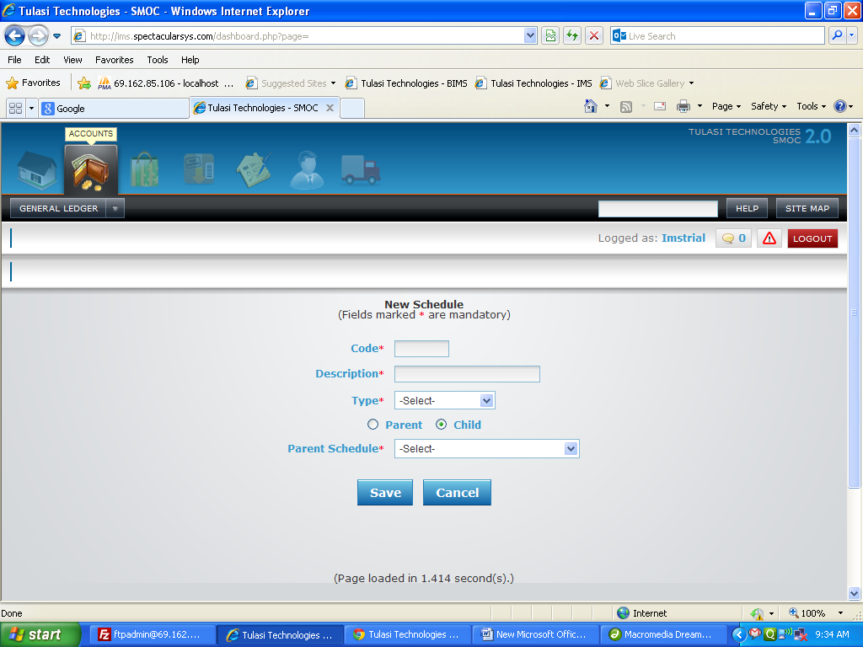

Basic Functionality:

1. This form is used to define the new schedule of parent and child.

2. Here we have to give unique code and description.

3. After we have to select the type.

4. If we select child means corresponding child schedule will load.

5. After we have to select the parent/child schedule.

Effecting Tables:

* ac_schedule.

Chart Of Accounts:

Screen Shot:

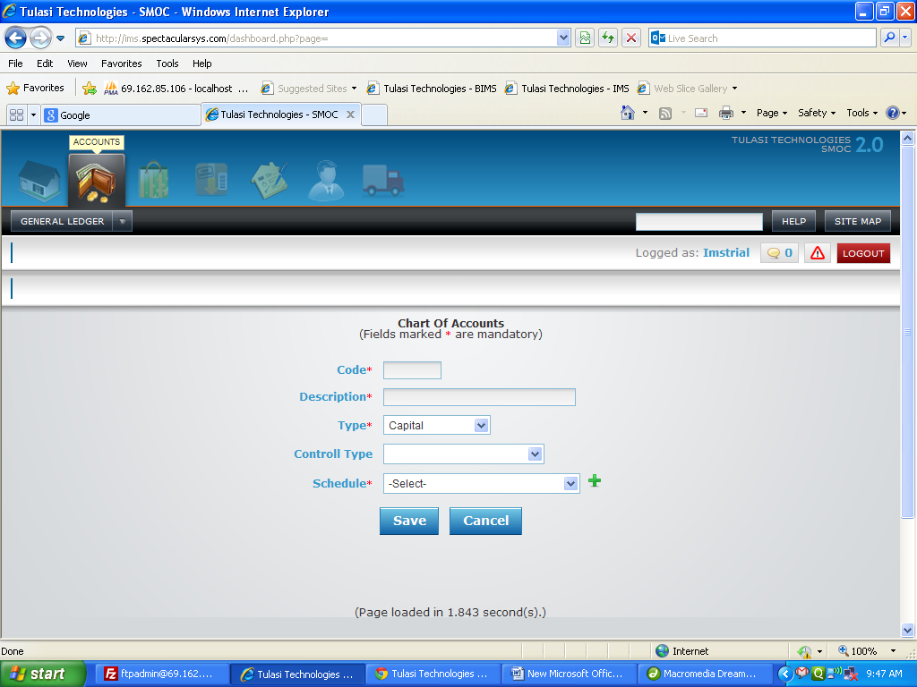

Basic Functionality:

1. This form is used to create chart of account of particular type.

2. Here we have to enter code and descriptions which are should be unique.

3. After we have to select the type. Based on Corresponding control types will load.

4. Then we have to select control type and schedule

Effecting Tables:

* ac_coa.
* ac_schedule.

Bank/Cash Codes:

Screen Shot:

~~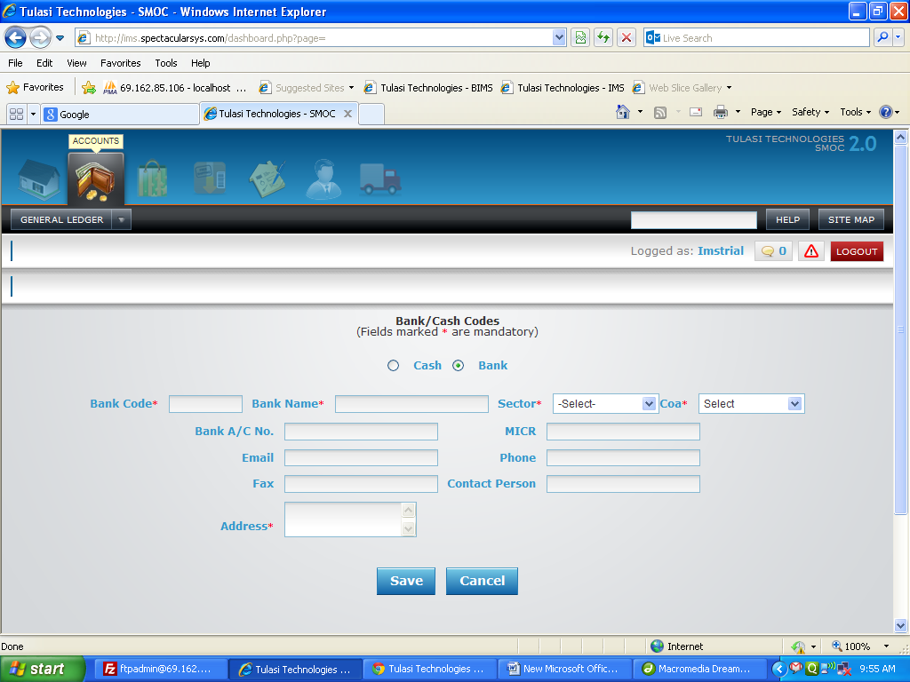~~

Basic Functionality:

1. This form is used to create bank and cash codes.

2. Here if you select cash means corresponding form will load and if you select bank corresponding to that form will load.

3. Here you have to enter code and description for both bank and cash.

4. After select sector and coa. And if it is bank code means you have to enter A/C no.

Effecting Tables:

* ac_bankcashcodes.
* ac_bankmasters.

Transactions

Payment Voucher:

Screen Shot:

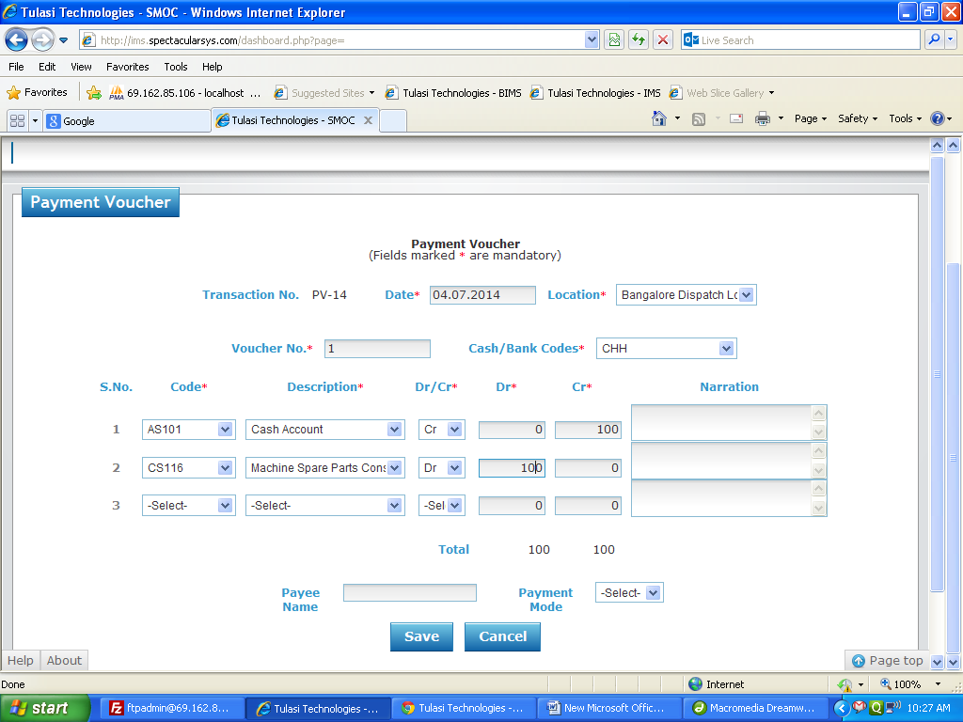

Basic Functionality:

1. This form is used to pay some amount to anyone.

2 .Here location will load from tbl_sector and cash/bank will load from ac_bankmasters.

3. On selection of cash/bank corresponding coa, code and description will be loaded.

4. For dynamic rows we will get codes and descriptions from ac_coa where type is not like revenue and schedule should not be 'Inventories', 'Inventories Work In Progress', 'Trade Receivable', 'Trade Payable', 'Cost Of Sales /Services', 'Price Variance', 'Production Variance'.

5. Here both credit and debit sum should be match.

Financial Impact:

|  |  |  |  |  |  |  |  |  |
| --- | --- | --- | --- | --- | --- | --- | --- | --- |
| Item code | Crdr | Coa code | Quantity | Amount | Trnum | Type | Venname | Warehouse |
|  | Cr | AS101 |  | 100 | PV-14 | PV |  | Bangalore Dispatch Location |
|  | Dr | CS116 |  | 100 | PV-14 | PV |  | Bangalore Dispatch Location |

Effecting Tables:

* ac_financialpostings.
* ac_gl.

Receipt Voucher:

Screen Shot:

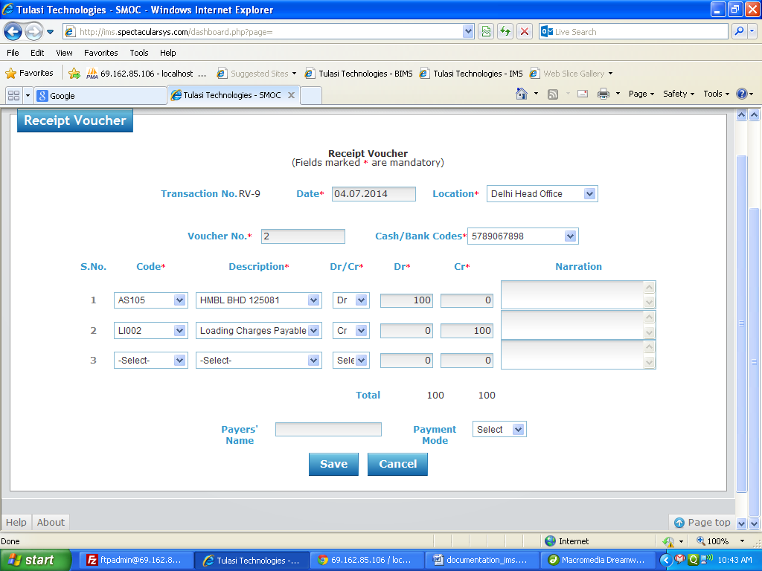

Basic Functionality:

1. This form is used to receive amount.

2 .Here location will load from tbl_sector and cash/bank will load from ac_bankmasters.

3. On selection of cash/bank corresponding coa, code and description will be loaded.

4. For dynamic rows we will get codes and descriptions from ac_coa where type is not like 'Expense' and schedule not in 'Inventories', 'Trade Payable', 'Trade Receivable', 'Inventories Work In Progress', 'Revenue from operations'.

5. Here both credit and debit sum should be match.

Financial Impact:

|  |  |  |  |  |  |  |  |  |
| --- | --- | --- | --- | --- | --- | --- | --- | --- |
| Item code | Crdr | Coa code | Quantity | Amount | Trnum | Type | Venname | Warehouse |
|  | Dr | AS105 |  | 100 | RV-9 | RV |  | Delhi Head Office |
|  | Cr | LI002 |  | 100 | RV-9 | RV |  | Delhi Head Office |

Effecting Tables:

* ac_financialpostings.
* ac_gl.

Journal Voucher:

Screen Shot:

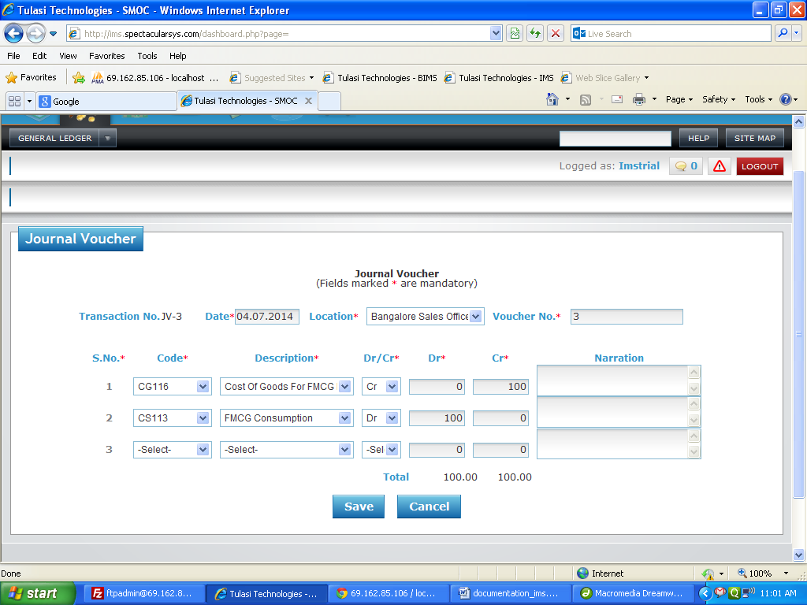

Basic Functionality:

1. This form is used to receive where cash and bank are not involved.

2 .Here location will load from tbl_sector.

3. We will get codes and descriptions from ac_coa where control type is null.

4. Here both credit and debit sum should be match.

Financial Impact:

|  |  |  |  |  |  |  |  |  |
| --- | --- | --- | --- | --- | --- | --- | --- | --- |
| Item code | Crdr | Coa code | Quantity | Amount | Trnum | Type | Venname | Warehouse |
|  | Cr | CG116 |  | 100 | JV-3 | JV |  | Bangalore Sales Office |
|  | Dr | CS113 |  | 100 | JV-3 | JV |  | Bangalore Sales Office |

Effecting Tables:

* ac_financialpostings.
* ac_gl.

**Procure To Pay**

**Masters**

Create Supplier:

Screen Shot:

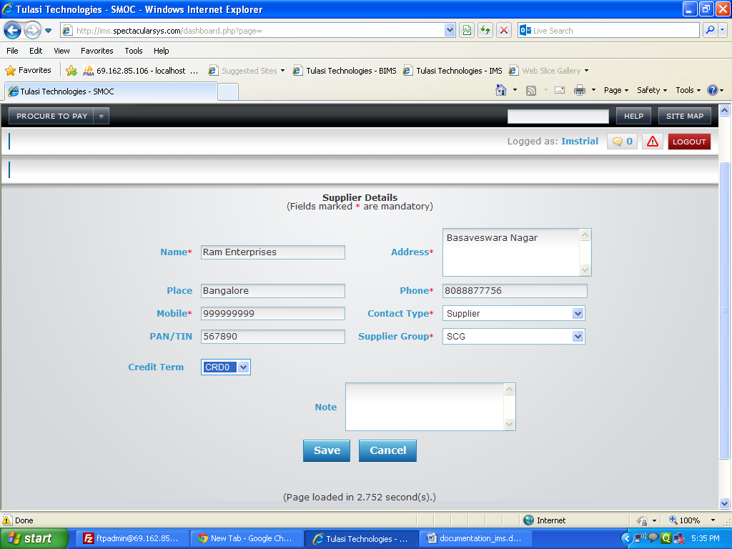

Basic Functionality:

1. This form is used to store the details of supplier like name, address and to which group the supplier belongs and credit term of supplier.

Effecting Tables:

* contactdetails.

Tax Masters:

Screen Shot:

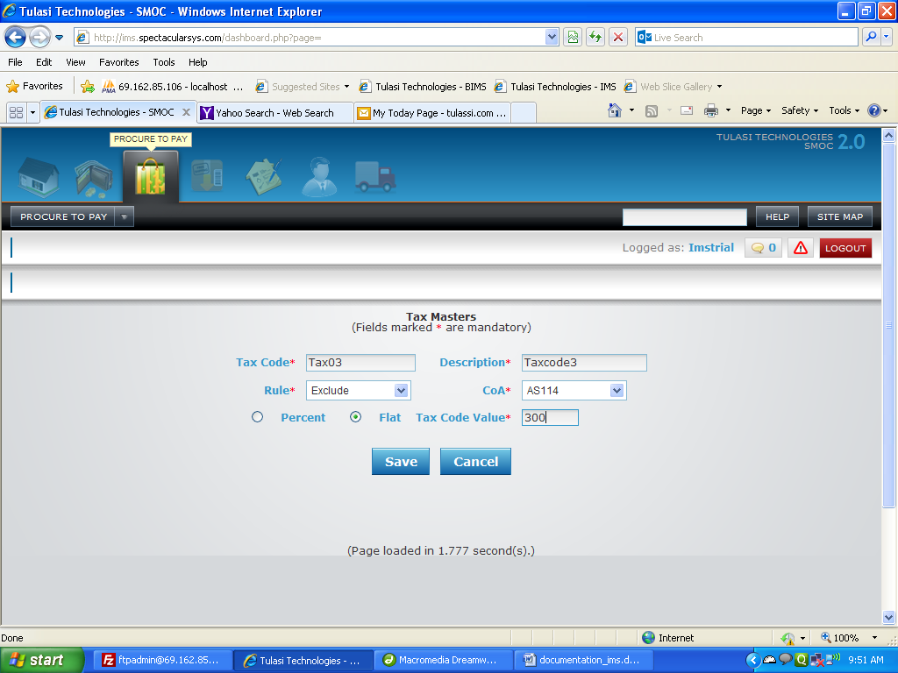

Basic Functionality:

1. This form is used to create the tax codes.

2. Here first we have to enter the tax code and description

3. Here you have to select the rule i.e weather it is include or exclude. After select coa.

4. Select percent or flat. If you select flat means enter amount and if you select percent enter the percentage.

Effecting Tables:

* ims_taxmasters.

Vendor Group Mapping:

Screen Shot:

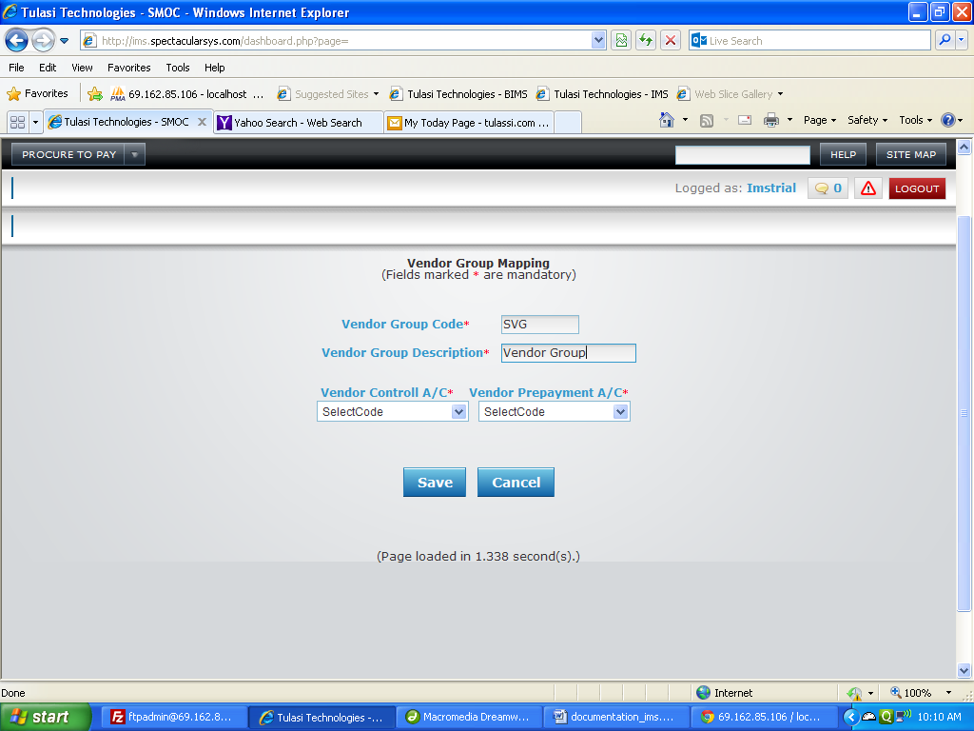

Basic Functionality:

1. This form is used to create the vendor group.

2. Here first we have to enter the vendor group code and description

3. Here you have to select the vendor control A/C and vendor prepayment A/C.

4. Vendor control A/C and vendor prepayment A/C should be unique for every vendor group.

Effecting Tables:

* ac_vgrmap.

Credit Term:

Screen Shot:

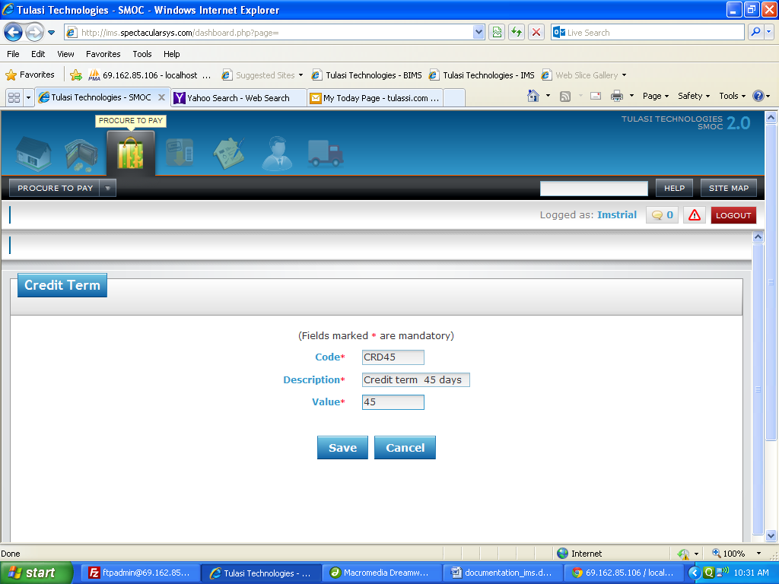

Basic Functionality:

1. This form is used to create the Credit Term.

2. Here first we have to enter the credit term code, description and value.

Effecting Tables:

* ims_creditterm.

Transactions

Purchase Request:

Screen Shot:

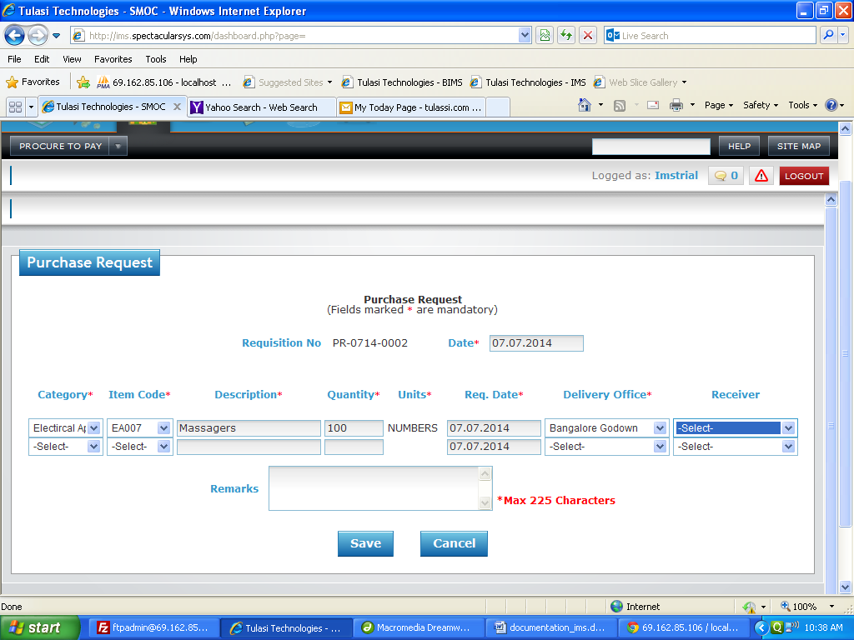

Basic Functionality:

1. This form is used to enter the purchase request.

2. Here you need to select the category. On selection of category corresponding item codes will load. On selection of code, description and units will come automatically.

3. You need to enter how much quantity you are requesting and from which delivery office that item has delivered and enter on which date you were requested.

Effecting Tables:

* pp_purchaseindent.

Purchase Order:

Purchase Order Without Request:

Screen Shot:

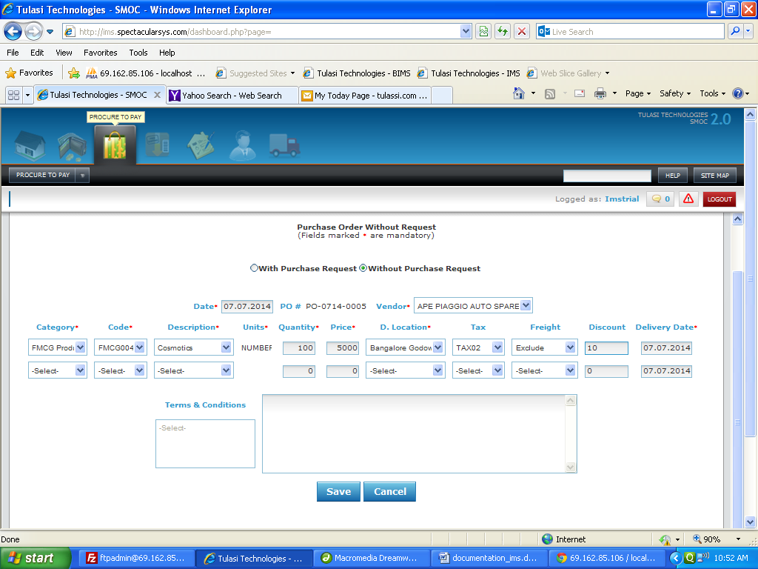

Basic Functionality:

1. This form is used to enter the purchase order.

2. You need to select the vendor to whom you want to give the order.

3. Here you need to select the category. On selection of category corresponding item codes and description will load. On selection of code, description and units will come automatically.

4. You need to enter how much quantity you are ordering and from which delivery office that item has delivered and enter on which date you were requested.

5. If you need tax you can select tax code and you want freight you can select which type freight you required.

6. You can enter the discount for that particular item.

7. You can select on which date you want to be delivered.

Effecting Tables:

* pp_purchaseorder.

Purchase Order With Request:

Screen Shot:

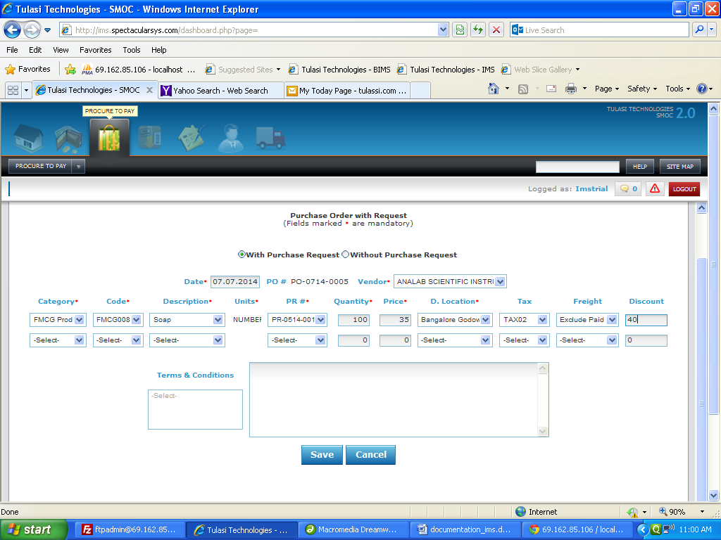

Basic Functionality:

1. This form is used to enter the purchase order to which you have purchase request.

2. You need to select the vendor to whom you want to give the order.

3. Here you need to select the category. On selection of category corresponding item codes and description will load. On selection of code, description and units will come automatically.

4. After you need to enter the purchase request number. Based on will get corresponding delivery location.

5. You need to enter how much quantity you are ordering and from which delivery office that item has delivered and enter on which date you were requested.

6. If you need tax you can select tax code and you want freight you can select which type freight you required.

7. You can enter the discount for that particular item.

Effecting Tables:

* pp_purchaseindent.
* pp_purchaseorder.

Goods Receipt:

Screen Shot:

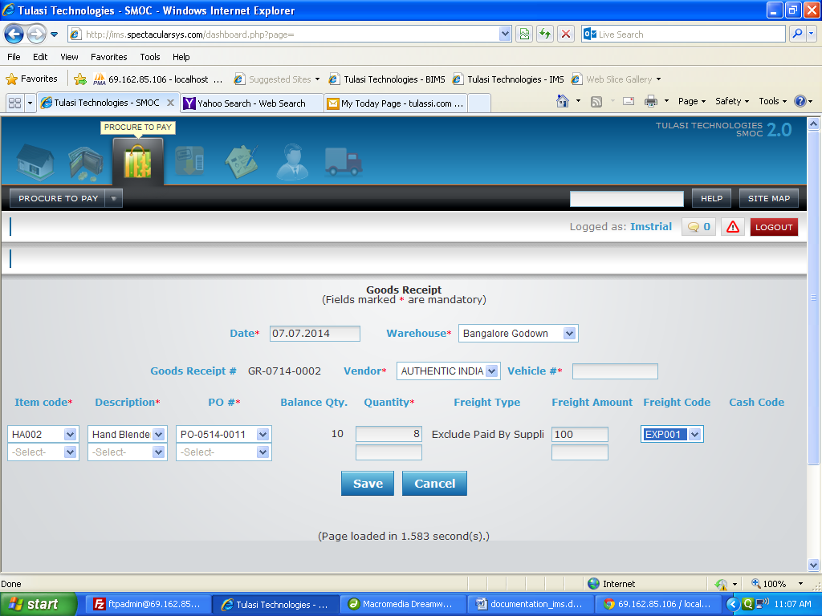

Basic Functionality:

1. This form is used for how much quantity you received.

2. Here you need to select the warehouse. Based on warehouse corresponding vendors has to be loaded from pp_purchaseorder.

3. You will get corresponding item codes for that particular vendor and warehouse from purchase order.

4. After selection of item code corresponding po number will load.

5. On selection po, balance quantity and freight type will come automatically.

6.

1. If the freight type is ‘excluded’ both freight code and cash code should be visible.
2. If the freight type is ‘included’ only cash code should be visible.
3. If the freight type is ‘excluded paid by supplier’ only freight code should be visible.
4. Otherwise both freight code and cash code should be invisible.

Financial Impact:

|  |  |  |  |  |  |  |  |  |
| --- | --- | --- | --- | --- | --- | --- | --- | --- |
| Item code | Crdr | Coa code | Quantity | Amount | Trnum | Type | Venname | Warehouse |
| HA002 | Dr | AS115 | 8 | 6658.66 | GR-0714-0002 | GR | Authentic India Handicrafts | Bangalore Godown |
| TAX01 | Dr | AS114 | 8 | 133.34 | GR-0714-0002 | GR | Authentic India Handicrafts | Bangalore Godown |
| SR112 | Dr | SR112 | 8 | 100 | GR-0714-0002 | GR | Authentic India Handicrafts | Bangalore Godown |
|  | Cr | AS110 | 8 | 6892 | GR-0714-0002 | GR | Authentic India Handicrafts | Bangalore Godown |

Effecting Tables:

* ac_financialpostings.
* pp_goodsreceipt.
* pp_purchaserder

Supplier Order Based Invoice:

Screen Shot:

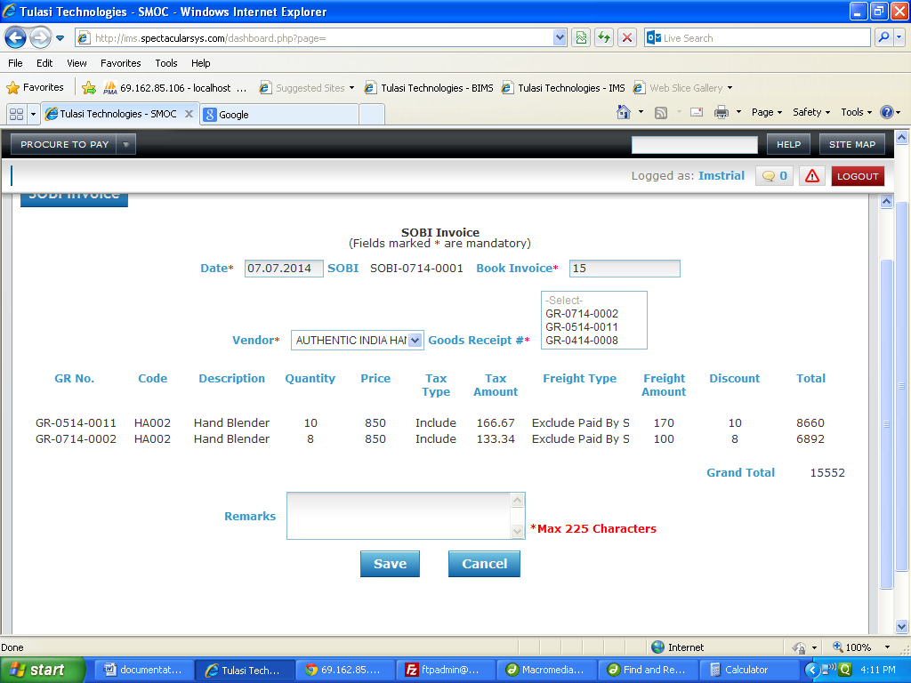

Basic Functionality:

1. This form is used for generating Invoice by combining the gr’s of vendor.

2. Here you need to select the vendor. Based on vendor corresponding gr’s has to be loaded from pp_goodsreceipt.

3. You will get corresponding item codes for that particulars of that selected goods receipt.

Financial Impact:

|  |  |  |  |  |  |  |  |  |
| --- | --- | --- | --- | --- | --- | --- | --- | --- |
| Item code | Crdr | Coa code | Quantity | Amount | Trnum | Type | Venname | Warehouse |
|  | Cr | LI111 | 18 | 15552 | SOBI-0714-0001 | SOBI | Authentic India Handicrafts | Bangalore Godown |
|  | Dr | AS110 | 18 | 15552 | SOBI-0714-0001 | SOBI | Authentic India Handicrafts | Bangalore Godown |

Effecting Tables:

* ac_financialpostings.
* pp_sobi.
* pp_ goodsreceipt

Direct Purchases:

Screen Shot:

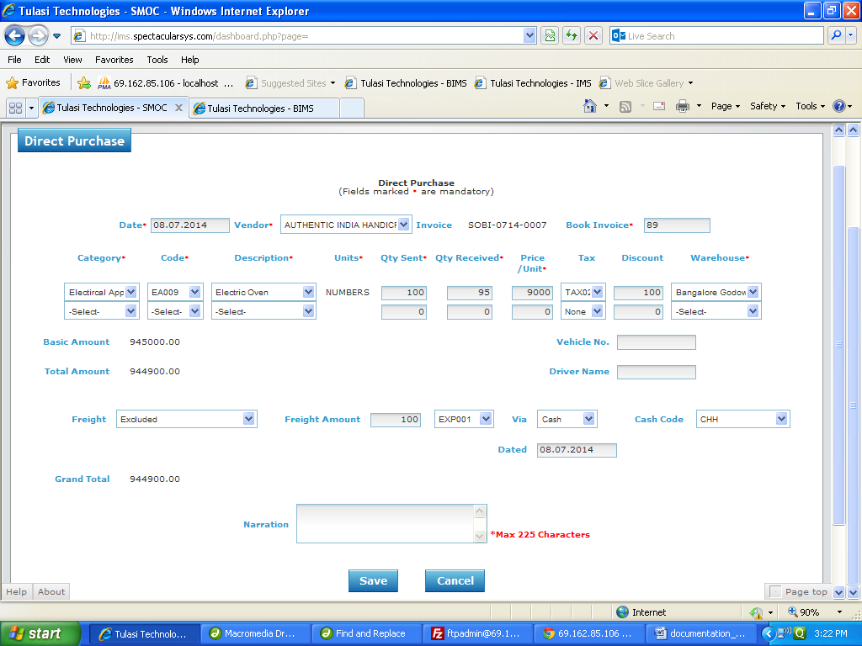

Basic Functionality:

1. This form is used for things which are purchased directly.

2. Here you need to select the vendor. After you need select the category

3. You will get corresponding item codes for of that selected category.

4. Here you have to enter how much quantity they sent to your godown and how much quantity you received and also enter the price of the item and to which warehouse the goods are received.

5. Here basic amount calculation has to be follow like this

Basic Amount=(Quantitysent*Price)+Taxamount;

Total Amount = Basic Amount-Discount

6. After you can select the freight type

1. If the freight type is ‘excluded’ both freight code and cash code should be visible.
2. If the freight type is ‘included’ only cash code should be visible.
3. If the freight type is ‘excluded paid by supplier’ only freight code should be visible.

7. Grand Total calculation will be like this Grand Total= Total Amount +Freight Amount

(Note: Freight amount calculation will b e based on which type you selected.)

Financial Impact:

|  |  |  |  |  |  |  |  |  |
| --- | --- | --- | --- | --- | --- | --- | --- | --- |
| Item code | Crdr | Coa code | Quantity | Amount | Trnum | Type | Venname | Warehouse |
|  | Cr | AS101 | 100 | 100 | SOBI-0714-0007 | SOBI | Authentic India Handicrafts | Hyderabad Godown |
|  | Dr | EXP001 | 100 | 100 | SOBI-0714-0007 | SOBI | Authentic India Handicrafts | Hyderabad Godown |
|  | Cr | LI111 | 100 | 944900 | SOBI-0714-0007 | SOBI | Authentic India Handicrafts | Hyderabad Godown |
| EA009 | Dr | AS114 | 95 | 899000 | SOBI-0714-0007 | SOBI | Authentic India Handicrafts | Hyderabad Godown |
|  |  |  |  |  |  |  |  |  |
| TAX02 | Dr | AS110 | 95 | 45000 | SOBI-0714-0007 | SOBI | Authentic India Handicrafts | Hyderabad Godown |

Effecting Tables:

* ac_financialpostings.
* pp_sobi.

Non Inventory Direct Purchases:

Screen Shot:

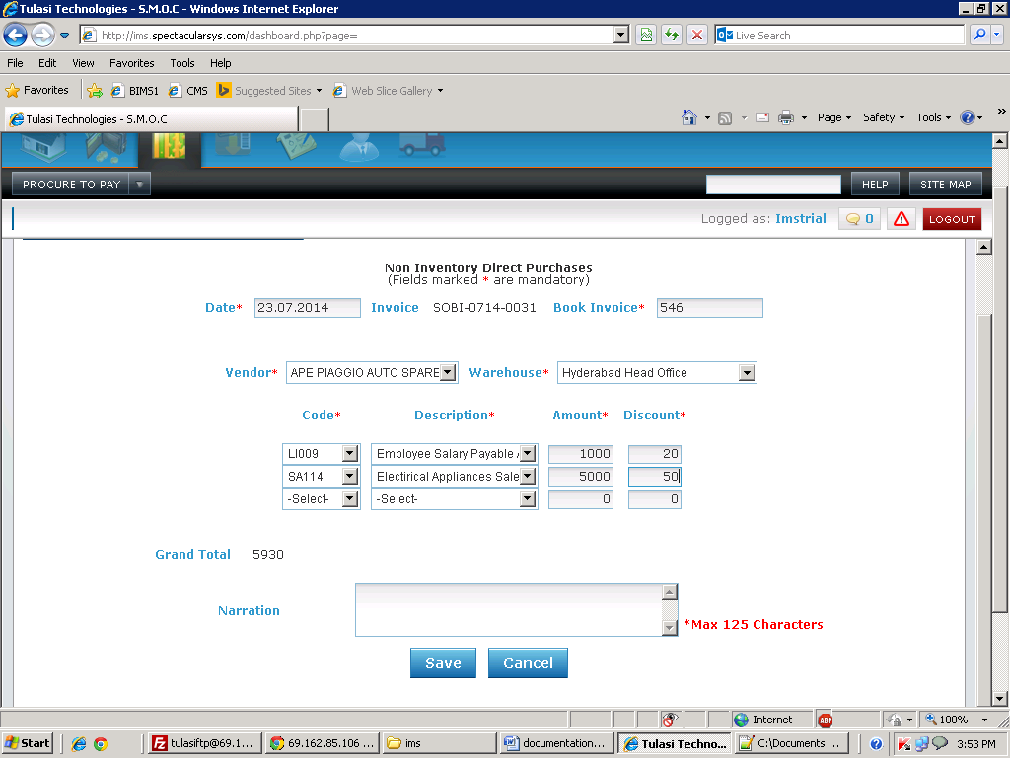

Basic Functionality:

1. This form is used for things which are purchased directly.

2. Here you need to select the vendor. After select warehouse

3. You have to select item code.

4. Here you have to enter amount and discount.

5. Here Grand amount calculation has to be follow like this

Grand Amount=Amount-Discount;

Financial Impact:

|  |  |  |  |  |  |  |  |  |
| --- | --- | --- | --- | --- | --- | --- | --- | --- |
| Item code | Crdr | Coa | Quantity | Amount | Trnum | Type | Venname | Warehouse |
|  | Dr | SA114 |  | 4950 | SOBI-0714-0031 | SOBI | Ape Piaggio Auto Spare Parts | Hyderabad Head Office |
|  | Dr | LI009 |  | 980 | SOBI-0714-0031 | SOBI | Ape Piaggio Auto Spare Parts | Hyderabad Head Office |
|  | Cr | LI111 |  | 5930 | SOBI-0714-0031 | SOBI | Ape Piaggio Auto Spare Parts | Hyderabad Head Office |
|  |  |  |  |  |  |  |  |

Effecting Tables:

* ac_financialpostings.
* pp_sobi.

Retail Purchases:

Screen Shot:

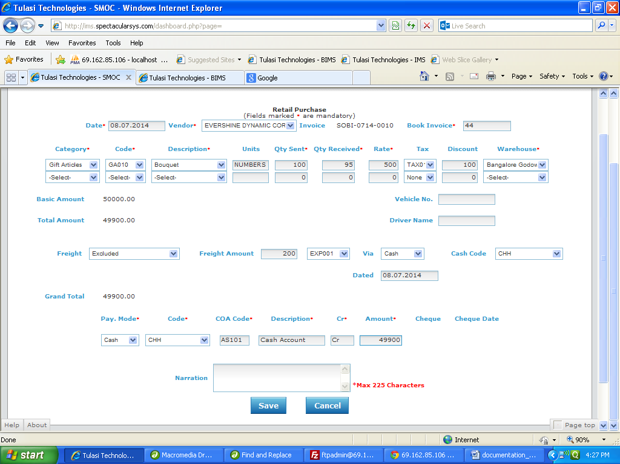

Basic Functionality:

1. This form is used for things which are purchased directly and pay cash directly to a vendor.

2. Here you need to select the vendor. After you need select the category

3. You will get corresponding item codes for of that selected category.

4. Here you have to enter how much quantity they sent to your warehouse and how much quantity you received and also enter the price of the item and to which warehouse the goods are received.

5. Here basic amount calculation has to be follow like this

Basic Amount=(Quantitysent*Price)+Taxamount;

Total Amount = Basic Amount-Discount

6. After you can select the freight type

1. If the freight type is ‘excluded’ both freight code and cash code should be visible.
2. If the freight type is ‘included’ only cash code should be visible.
3. If the freight type is ‘excluded paid by supplier’ only freight code should be visible.

7. Grand Total calculation will be like this Grand Total= Total Amount +Freight Amount

(Note: Freight amount calculation will b e based on which type you selected.)

8. After you can select the pay mode i.e. Weather you paid through cash or cheque to the vendor.

9.If select cash means cash codes has to be loaded and if you select cheque means A/C no. has to be loaded and cheque number field and cheque date has to be visible.

10. On selection of code description and coacode has to be loaded.

Financial Impact:

|  |  |  |  |  |  |  |  |  |
| --- | --- | --- | --- | --- | --- | --- | --- | --- |
| Item code | Crdr | Coa code | Quantity | Amount | Trnum | Type | Venname | Warehouse |
|  | Cr | AS101 | 100 | 200 | SOBI-0714-0010 | SOBI | Evershine Dynamic Corporation Limited | Bangalore Godown |
|  | Dr | EXP001 | 100 | 200 | SOBI-0714-0010 | SOBI | Evershine Dynamic Corporation Limited | Bangalore Godown |
| GA010 | Dr | AS117 | 95 | 48919.61 | SOBI-0714-0010 | SOBI | Evershine Dynamic Corporation Limited | Bangalore Godown |
| TAX01 | Dr | AS114 | 95 | 980.39 | SOBI-0714-0010 | SOBI | Evershine Dynamic Corporation Limited | Bangalore Godown |
|  |  |  |  |  |  |  |  |  |
| TAX02 | Dr | AS110 | 95 | 45000 | SOBI-0714-0010 | SOBI | Evershine Dynamic Corporation Limited | Bangalore Godown |
|  | Cr | AS101 | 0 | 49900 | 11 | PMT | Evershine Dynamic Corporation Limited | Bangalore Godown |

Effecting Tables:

* ac_financialpostings.
* pp_sobi.
* pp_payment.

Purchase Return:

Screen Shot:

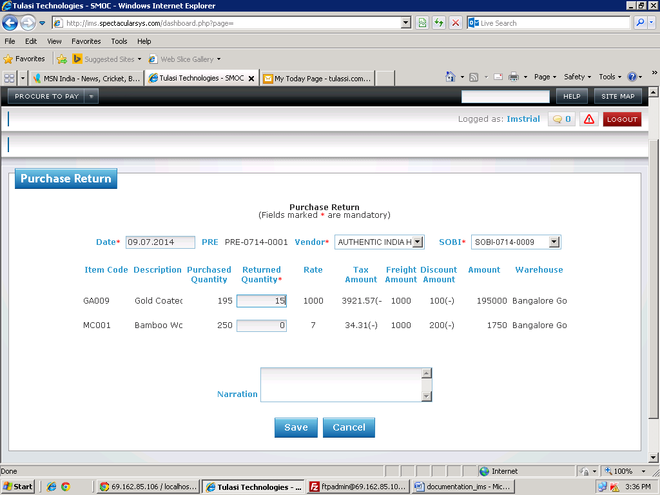

Basic Functionality:

1. This form is used for items which are returned to the vendor..

2. Here you need to select the vendor. After you need select the SOBI.

3. You need to select date..

4. Based on SOBI corresponding item codes and how much quantity you purchased and tax, freight and discount information also has to display.. Here you can enter how much quantity you want to return.

Financial Impact:

|  |  |  |  |  |  |  |  |  |
| --- | --- | --- | --- | --- | --- | --- | --- | --- |
| Item code | Crdr | Coa code | Quantity | Amount | Trnum | Type | Venname | Warehouse |
| GA009 | Cr | AS117 | 15 | 15000 | PRE-0714-0001 | PPRTN | Authentic India Handicrafts | Bangalore Godown |
| GA009 | Dr | LI111 | 15 | 15000 | PRE-0714-0001 | PPRTN | Authentic India Handicrafts | Bangalore Godown |

Effecting Tables:

* ac_financialpostings.
* pp_purchasereturn.

Payment:

Screen Shot:

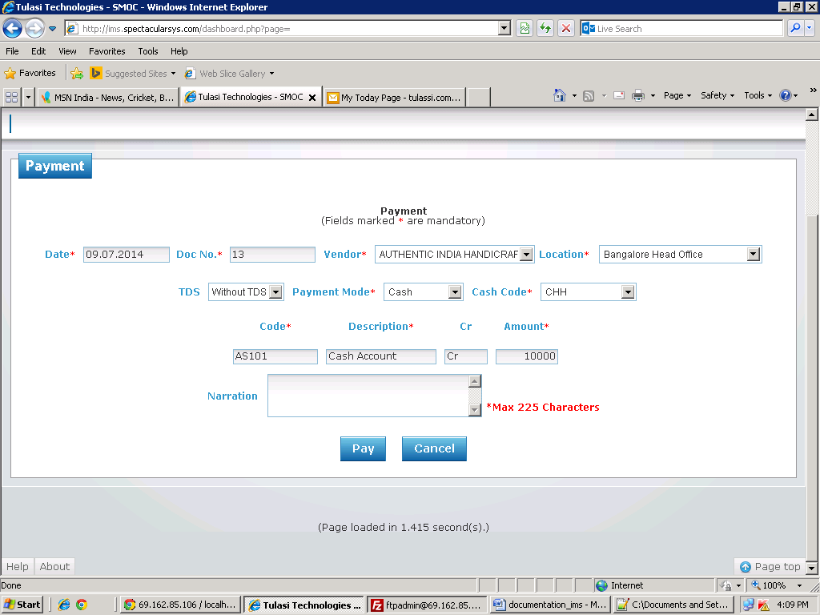

Basic Functionality:

1. This form is used for giving the payment to the vendor.

2. Here you need to select the vendor. After you need to which location you are paying the amount.

3. You need to select date and payment mode.

4. If you select cash then cash codes has to be loaded and if you select cash or transfer A/C no’s has to be loaded.

5. On selection of cash code or A/C no’s corresponding coacode and description will come automatically.

6.After enter amount to pay to the vendor.

7. Here if you select TDS dynamic row will generate.

Financial Impact:

|  |  |  |  |  |  |  |  |  |
| --- | --- | --- | --- | --- | --- | --- | --- | --- |
| Item code | Crdr | Coa code | Quantity | Amount | Trnum | Type | Venname | Warehouse |
|  | Cr | AS101 | 0 | 1000 | |  | | --- | | 35 | | PMT | Authentic India Handicrafts | Bangalore Head Office |
|  | Dr | LI111 | 0 | 1000 | 35 | PMT | Authentic India Handicrafts | Bangalore Head Office |

Effecting Tables:

* ac_financialpostings.
* pp_payment.

Receipt:

Screen Shot:

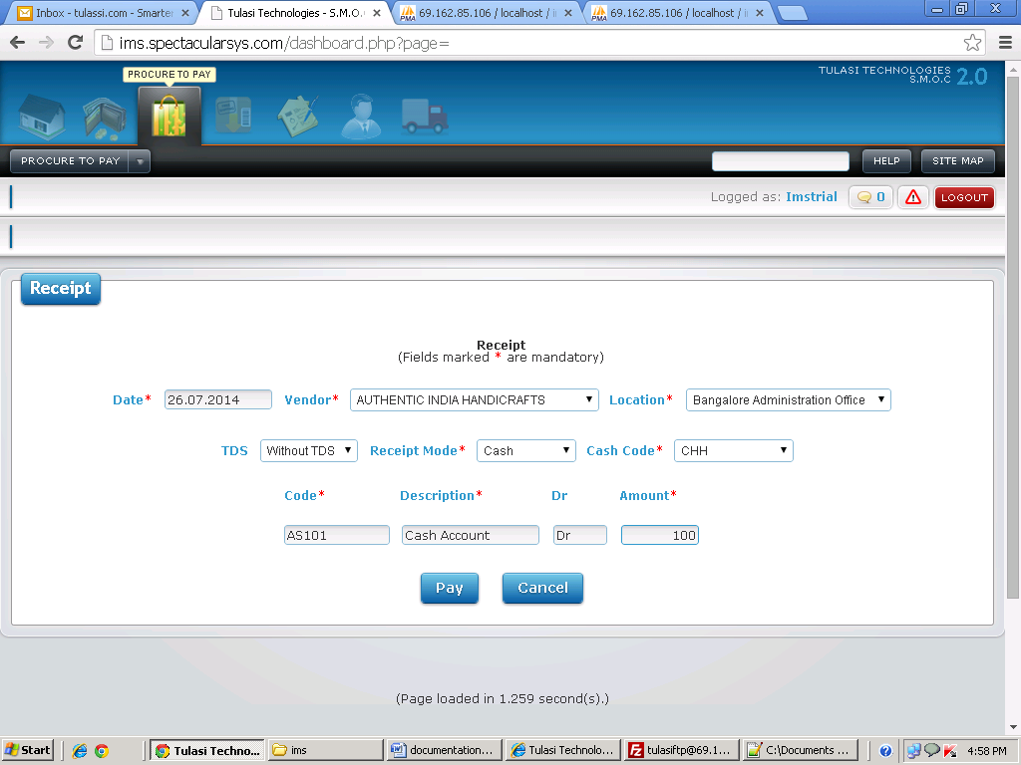

Basic Functionality:

1. This form is used for getting the amount to the vendor..

2. Here you need to select the vendor. After you need to which location you are paying the amount.

3. You need to select date and payment mode.

4. If you select cash then cash codes has to be loaded and if you select cash or transfer A/C no’s has to be loaded.

5. On selection of cash code or A/C no’s corresponding coacode and description will come automatically.

6.After enter amount to pay to the vendor.

7. Here if you select TDS dynamic row will generate.

Financial Impact:

|  |  |  |  |  |  |  |  |  |
| --- | --- | --- | --- | --- | --- | --- | --- | --- |
| Item code | Crdr | Coa code | Quantity | Amount | Trnum | Type | Venname | Warehouse |
|  | Dr | AS101 | 0 | 100 | 35 | PPRCT | Authentic India Handicrafts | Bangalore Administration Office |
|  | Cr | LI111 | 0 | 100 | 35 | PPRCT | Authentic India Handicrafts | Bangalore Administration Office |

Effecting Tables:

* ac_financialpostings.
* pp_receipt.

Credit Note:

Screen Shot:

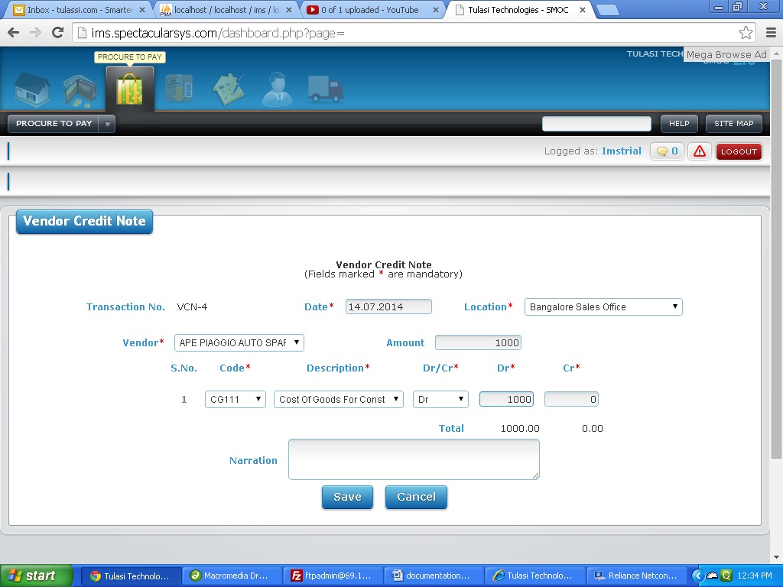

Basic Functionality:

1. This form is used for adjustments. It shows how much amount you need to pay the vendor.

2. Here you need to select the vendor. After you need to select location.

3. You need to select date and enter how much amount to adjust.

4. You need to select the code and description. Here the difference between sum of amounts of credit and debits should be equal to the amount

Financial Impact:

|  |  |  |  |  |  |  |  |  |
| --- | --- | --- | --- | --- | --- | --- | --- | --- |
| Item code | Crdr | Coa code | Quantity | Amount | Trnum | Type | Venname | Warehouse |
|  | Dr | CG111 |  | 1000 | VCN-4 | VCN | Ape Piaggio Auto Spare Parts | Bangalore Sales Office |
|  | Cr | LI111 |  | 1000 | VCN-4 | VCN | Ape Piaggio Auto Spare Parts | Bangalore Sales Office |

Effecting Tables:

* ac_financialpostings.
* ac_crdrnote.

Debit Note:

Screen Shot:

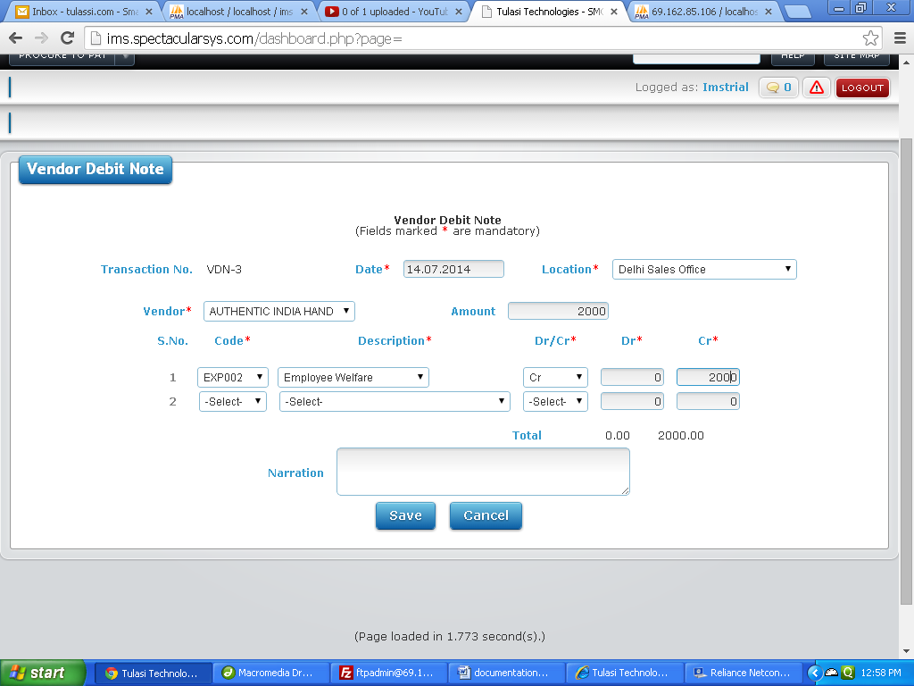

Basic Functionality:

1. This form is used for adjustments. It is used for how much amount you need get from vendor.

2. Here you need to select the vendor. After you need to select from which location you are getting amount.

3. You need to select date and enter how much amount to adjust.

4. You need to select the code and description. Here the difference between sum of amounts of credit and debits should be equal to the amount

Financial Impact:

|  |  |  |  |  |  |  |  |  |
| --- | --- | --- | --- | --- | --- | --- | --- | --- |
| Item code | Crdr | Coa code | Quantity | Amount | Trnum | Type | Venname | Warehouse |
|  | Dr | LI111 |  | 2000 | VDN-3 | VDN | Authentic India Handicrafts | Delhi Sales Office |
|  | Cr | EXP002 |  | 2000 | VDN-3 | VDN | Authentic India Handicrafts | Delhi Sales Office |

Effecting Tables:

* ac_financialpostings.
* ac_crdrnote.

**Order To Cash**

**Masters**

Create Customer:

Screen Shot:

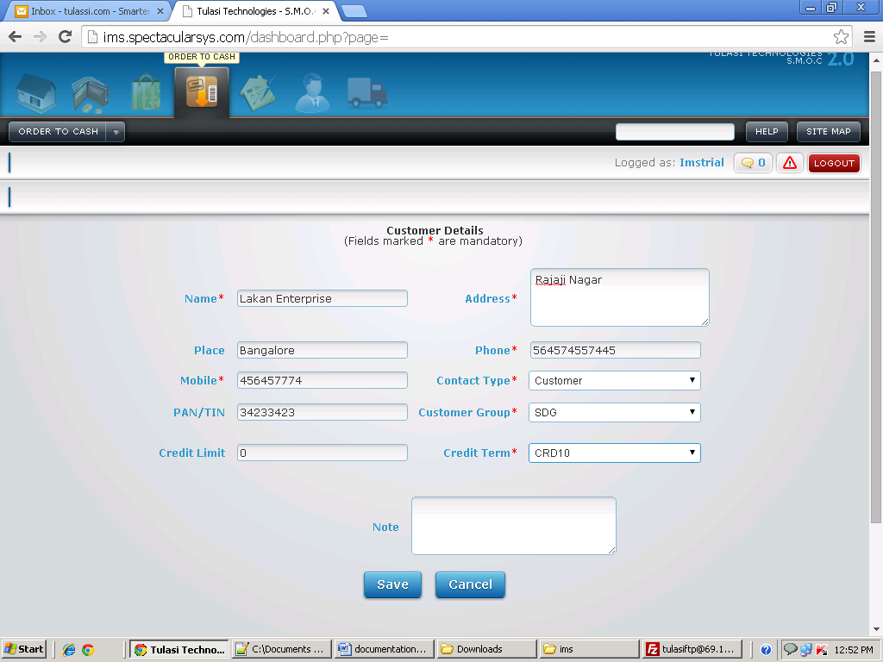

Basic Functionality:

1. This form is used to store the details of customer like name, address and to which group the customer belongs and credit term of supplier.

Effecting Tables:

* contactdetails.

Tax Masters:

Screen Shot:

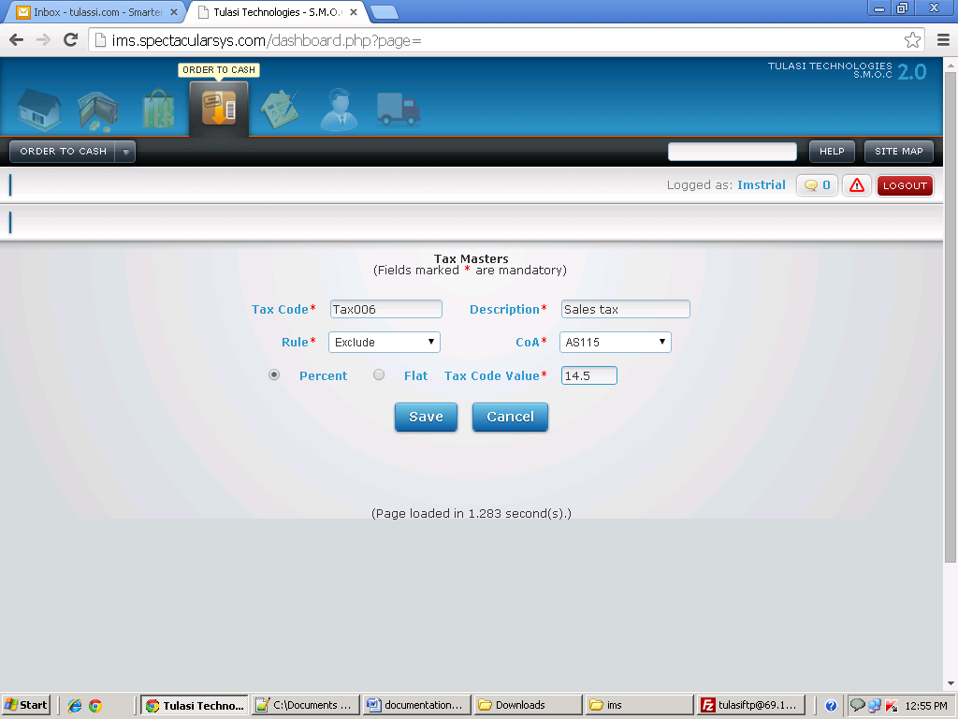

Basic Functionality:

1. This form is used to create the tax codes.

2. Here first we have to enter the tax code and description

3. Here you have to select the rule i.e weather it is include or exclude. After select coa.

4. Select percent or flat. If you select flat means enter amount and if you select percent enter the percentage.

Effecting Tables:

* ims_taxmasters.

Customer Group Mapping:

Screen Shot:

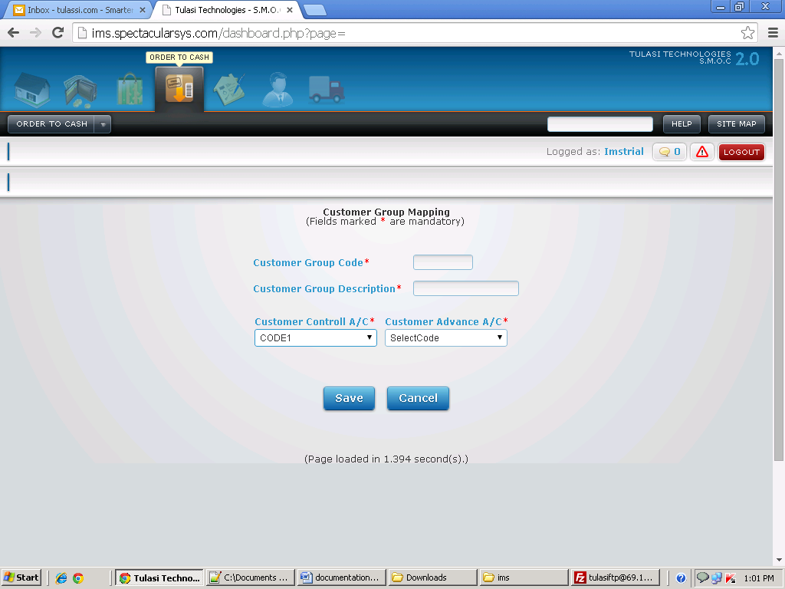

Basic Functionality:

1. This form is used to create the Customer group.

2. Here first we have to enter the Customer group code and description

3. Here you have to select the customer control A/C and customer advance A/C.

4. Customer control A/C and Customer Advance A/C should be unique for every vendor group.

Effecting Tables:

* ac_vgrmap.

Credit Term:

Screen Shot:

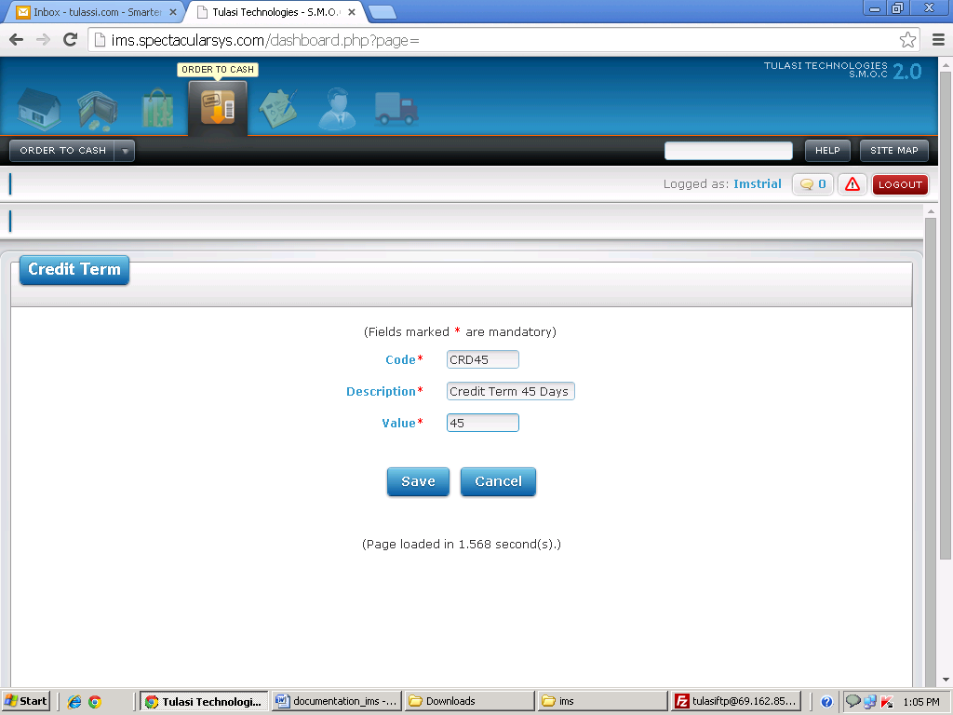

Basic Functionality:

1. This form is used to create the Credit Term.

2. Here first we have to enter the credit term code, description and value.

Effecting Tables:

* ims_creditterm.

Terms & Conditions:

Screen Shot:

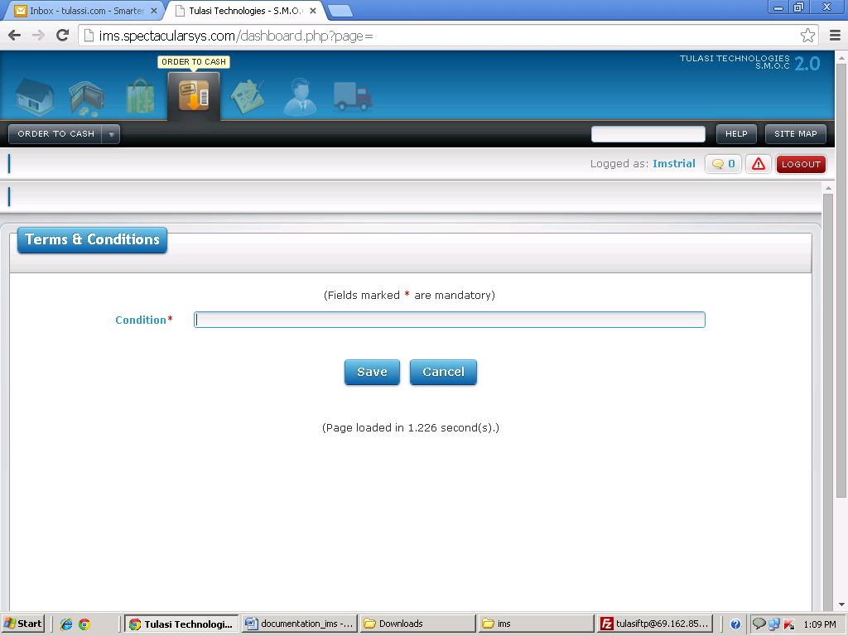

Basic Functionality:

1. This form is used to enter terms and conditions.

2. Here you have to enter condition.

Effecting Tables:

* Oc_tandc.

Sales Order:

Screen Shot:

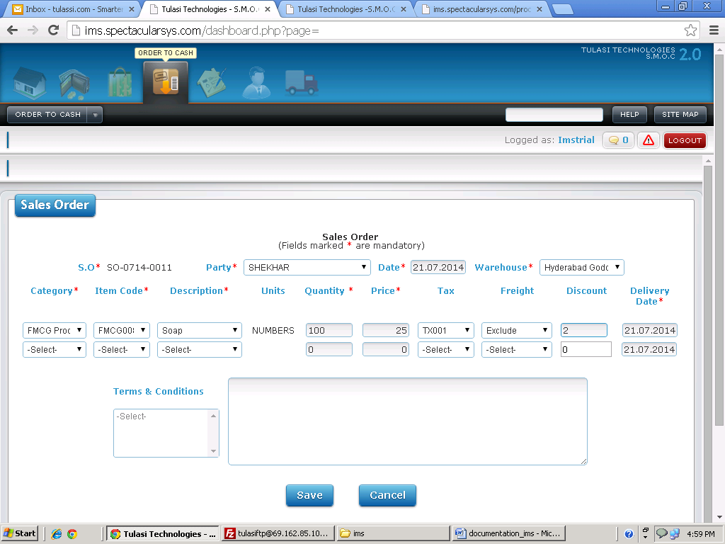

Basic Functionality:

1. This form is used to enter the sales order.

2. You need to select the party to whom you want to give the order 7and you need to select the warehouse.

3. Here you need to select the category. On selection of category corresponding item codes and description will load. On selection of code, description and units will come automatically.

4. You need to enter how much quantity you required.

5. If you need tax you can select tax code and you want freight you can select which type freight you required.

6. You can enter the discount for that particular item.

7. You can select on which date you want to be delivered.

Effecting Tables:

* oc_salesorder.

Pack Slip:

Screen Shot:

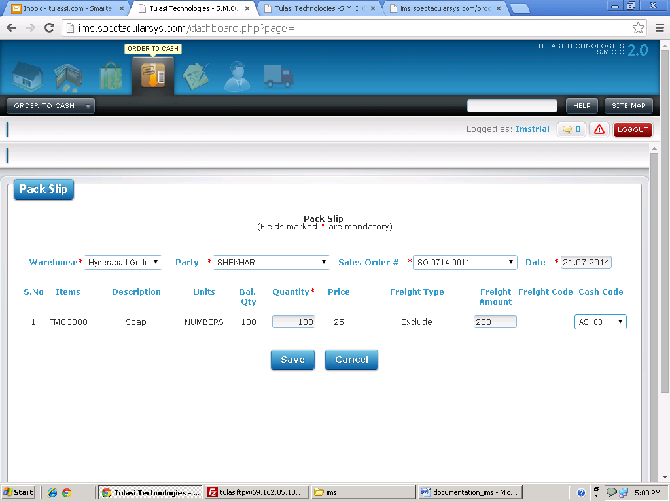

Basic Functionality:

1. This form is used for how much quantity you want sent.

2. Here you need to select the warehouse. Based on warehouse corresponding party has to be loaded from oc_Salesorder.

3. After that you have to select the sales order number.

4. You will get all the information of item codes and how much quantity you need to sent and what is the freight type. And you have a provision to enter how much quantity you are sending.

1. These are the following conditions you need to follow for freight.
2. Here if the freight type is ‘Exclude’ means cash code has to be visible.
3. Here if the freight type is ‘Include’ means both cash code and freight code have to be visible.
4. Here if the freight type is ‘Include Paid By Customer’ means freight code has to be visible.
5. Here you have to keep the stock checks. i.e if stock is available only entry has to be save in packslip. Otherwise, entry should not save in packslip and financialpostings

Financial Impact:

|  |  |  |  |  |  |  |  |  |
| --- | --- | --- | --- | --- | --- | --- | --- | --- |
| Item code | Crdr | Coa code | Quantity | Amount | Trnum | Type | Venname | Warehouse |
| FMCG008 | Cr | AS113 | 100 | 1520 | PS-0714-0005 | PS | Shekhar | Hyderabad Godown |
| FMCG008 | Dr | AS114 | 100 | 1520 | PS-0714-0005 | PS | Shekhar | Hyderabad Godown |

Effecting Tables:

* ac_financialpostings.
* Oc_packslip.
* Oc_salesorder.

Customer Order Based Invoice:

Screen Shot:

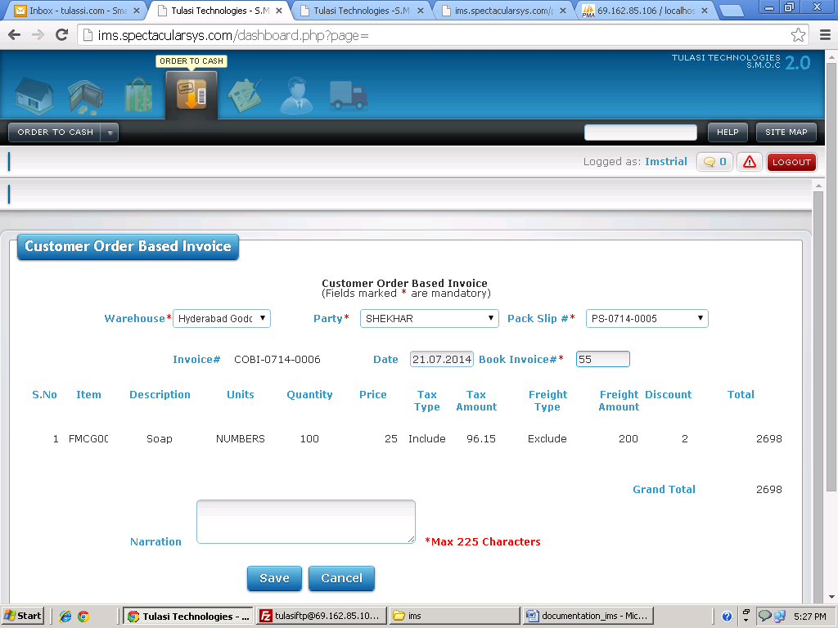

Basic Functionality:

1. This form is used for generating Invoice for a particular packslip.

2. Here you need to select the warehouse. Based on warehouse corresponding party has to be loaded from oc_packslip. Based on party packslip has to be loaded

3. You will get corresponding item codes for that particulars of that selected packslip.

Financial Impact:

|  |  |  |  |  |  |  |  |  |
| --- | --- | --- | --- | --- | --- | --- | --- | --- |
| Item code | Crdr | Coa code | Quantity | Amount | Trnum | Type | Venname | Warehouse |
| FMCG008 | Dr | AS121 | 0 | 2698 | COBI-0714-0006 | COBI | Shekhar | Hyderabad Godown |
| FMCG008 | Cr | AS180 | 100 | 200 | COBI-0714-0006 | COBI | Shekhar | Hyderabad Godown |
| TX001 | Cr | AS114 | 100 | 96.15 | COBI-0714-0006 | COBI | Shekhar | Hyderabad Godown |
|  |  |  |  |  |  |  |  |  |
| FMCG008 | Cr | SA113 | 100 | 2401.85 | COBI-0714-0006 | COBI | Shekhar | Hyderabad Godown |

Effecting Tables:

* ac_financialpostings.
* pp_sobi.
* pp_ goodsreceipt

Direct Sales:

Screen Shot:

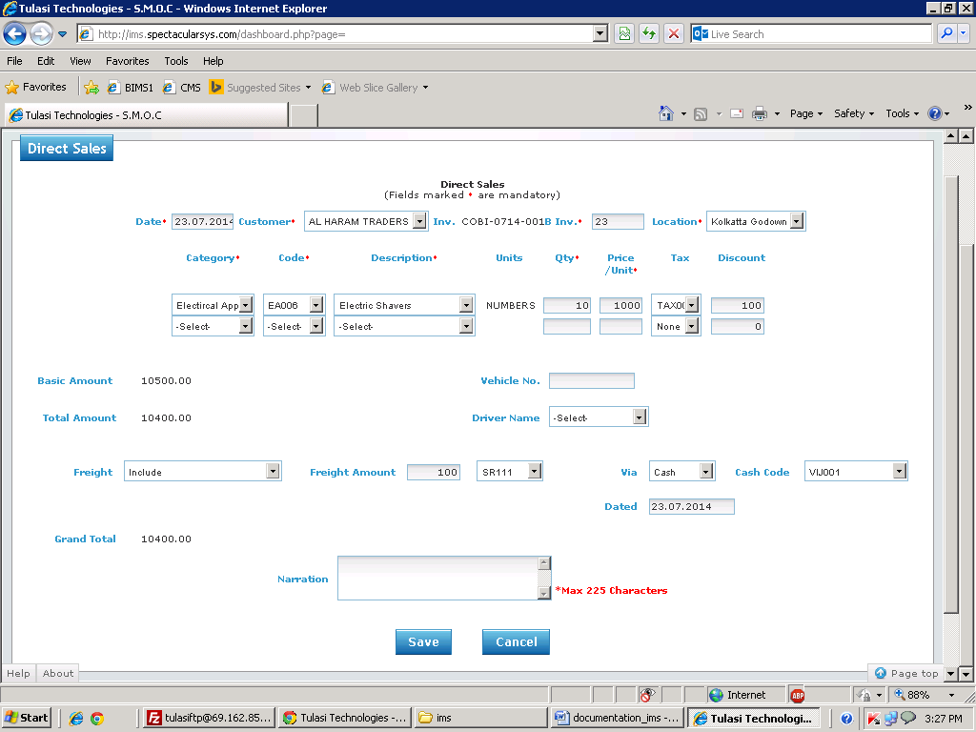

Basic Functionality:

1. This form is used for which things you want sell directly..

2. Here you need to select the Customer. After you need to select from which warehouse items you are selling. After you need select the category

3. You will get corresponding item codes for of that selected category.

4. Here you have to enter how much quantity you are selling and also enter the price of the item..

5. Here basic amount calculation has to be follow like this

Basic Amount=(Quantity*Price)+Taxamount;

Total Amount = Basic Amount-Discount

6. After you can select the freight type

1. If the freight type is ‘Include’ both freight code and cash code should be visible.
2. If the freight type is ‘Exclude’ only cash code should be visible.
3. If the freight type is ‘Include Paid By Customer’ only freight code should be visible.

7. Grand Total calculation will be like this Grand Total= Total Amount +Freight Amount

(Note: Freight amount calculation will b e based on which type you selected.)

Financial Impact:

|  |  |  |  |  |  |  |  |  |
| --- | --- | --- | --- | --- | --- | --- | --- | --- |
| Item code | Crdr | Coa code | Quantity | Amount | Trnum | Type | Venname | Warehouse |
| EA006 | Cr | AS101 | 10 | 9317.6 | COBI-0714-0017 | COBI | Al Haram Traders | Kolkatta Godown |
| EA006 | Dr | CG113 | 10 | 9317.6 | COBI-0714-0017 | COBI | Al Haram Traders | Kolkatta Godown |
| EA006 | Cr | SA114 |  | 9900 | COBI-0714-0017 | COBI | Al Haram Traders | Kolkatta Godown |
| TAX003 | Cr | AS115 | 10 | 500 | COBI-0714-0017 | COBI | Al Haram Traders | Kolkatta Godown |
|  |  |  |  |  |  |  |  |  |
|  | Cr | AS181 | 10 | 100 | COBI-0714-0017 | COBI | Al Haram Traders | Kolkatta Godown |
|  | Cr | SR111 | 10 | 100 | COBI-0714-0017 | COBI | Al Haram Traders | Kolkatta Godown |
|  | Dr | AS121 |  | 10400 | COBI-0714-0017 | COBI | Al Haram Traders | Kolkatta Godown |

Effecting Tables:

* ac_financialpostings.
* Oc_cobi.

Non Inventory Direct Sales:

Screen Shot:

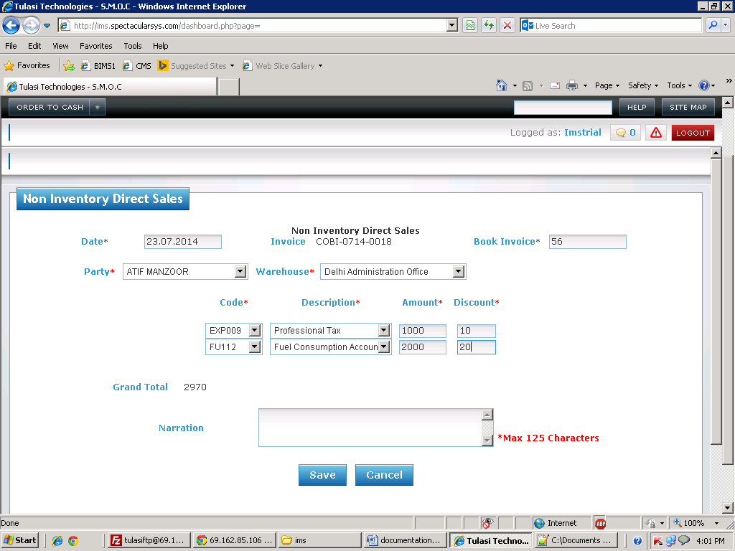

Basic Functionality:

1. This form is used for things which are selling of non inventory items.

2. Here you need to select the vendor. After you need select the warehouse

3. You have to select item code.

4. Here you have to enter amount and discount.

5. Here Grand amount calculation has to be follow like this

Grand Amount=Amount-Discount;

Financial Impact:

|  |  |  |  |  |  |  |  |  |
| --- | --- | --- | --- | --- | --- | --- | --- | --- |
| Item code | Crdr | Coa | Quantity | Amount | Trnum | Type | Venname | Warehouse |
|  | Cr | FU112 | 0 | 1980 | COBI-0714-0018 | COBI | Atif Manzoor | Delhi Administration Office |
|  | Cr | EXP009 | 0 | 990 | COBI-0714-0018 | COBI | Atif Manzoor | Delhi Administration Office |
|  | Dr | AS121 | 0 | 2970 | COBI-0714-0018 | COBI | Atif Manzoor | Delhi Administration Office |
|  |  |  |  |  |  |  |  |

Effecting Tables:

* ac_financialpostings.
* Oc_cobi.

Retail Sales :

Screen Shot:

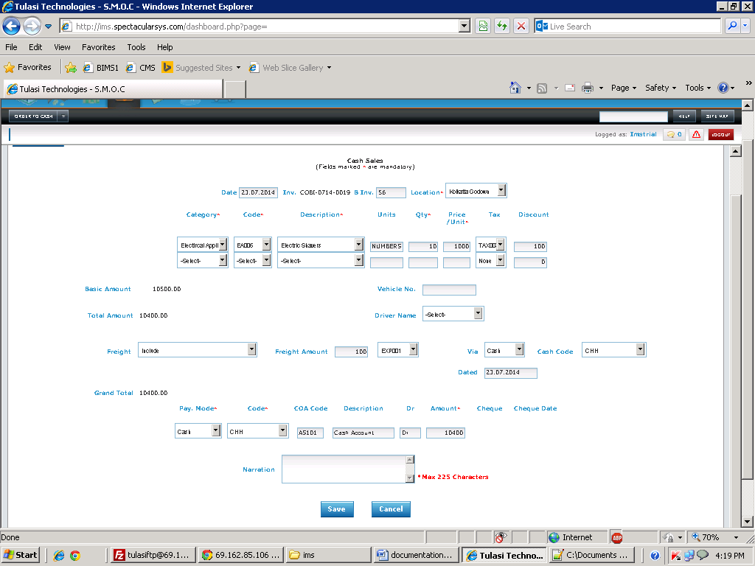

Basic Functionality:

1. This form is used for things which are selling directly and getting cash directly from customer.

2. Here you need to select the Location. After you need select the category

3. You will get corresponding item codes for of that selected category.

4. Here you have to enter how much quantity you are selling and also enter the price of the item.

5. Here basic amount calculation has to be follow like this

Basic Amount=(Quantitysent*Price)+Taxamount;

Total Amount = Basic Amount-Discount

6. After you can select the freight type

1. If the freight type is ‘Include’ both freight code and cash code should be visible.
2. If the freight type is ‘Exclude’ only cash code should be visible.
3. If the freight type is ‘Include Paid By Customer’ only freight code should be visible.
4. Grand Total calculation will be like this Grand Total= Total Amount +Freight Amount

(Note: Freight amount calculation will b e based on which type you selected.)

8. After you can select the pay mode i.e. Weather you are getting amount through cash or cheque from customer.

9.If select cash means cash codes has to be loaded and if you select cheque means A/C no. has to be loaded and cheque number field and cheque date has to be visible.

10. On selection of code description and coacode has to be loaded.

Financial Impact:

|  |  |  |  |  |  |  |  |  |
| --- | --- | --- | --- | --- | --- | --- | --- | --- |
| Item code | Crdr | Coa code | Quantity | Amount | Trnum | Type | Venname | Warehouse |
| EA006 | Cr | AS101 | 10 | 9317.6 | COBI-0714-0019 | COBI |  | Kolkatta Godown |
| EA006 | Dr | CG113 | 10 | 9317.6 | COBI-0714-0019 | COBI |  | Kolkatta Godown |
| EA006 | Cr | SA114 |  | 9900 | COBI-0714-0019 | COBI |  | Kolkatta Godown |
| TAX003 | Cr | AS115 | 10 | 500 | COBI-0714-0019 | COBI |  | Kolkatta Godown |
|  |  |  |  |  |  |  |  |  |
|  | Cr | AS181 | 10 | 100 | COBI-0714-0019 | COBI |  | Kolkatta Godown |
|  | Cr | SR111 | 10 | 100 | COBI-0714-0019 | COBI |  | Kolkatta Godown |
|  | Dr | As121 |  | 10400 | COBI-0714-0019 | COBI |  | Kolkatta Godown |

Effecting Tables:

* ac_financialpostings.
* Oc_cobi.
* Oc_receipt.

Sales Return:

Screen Shot:

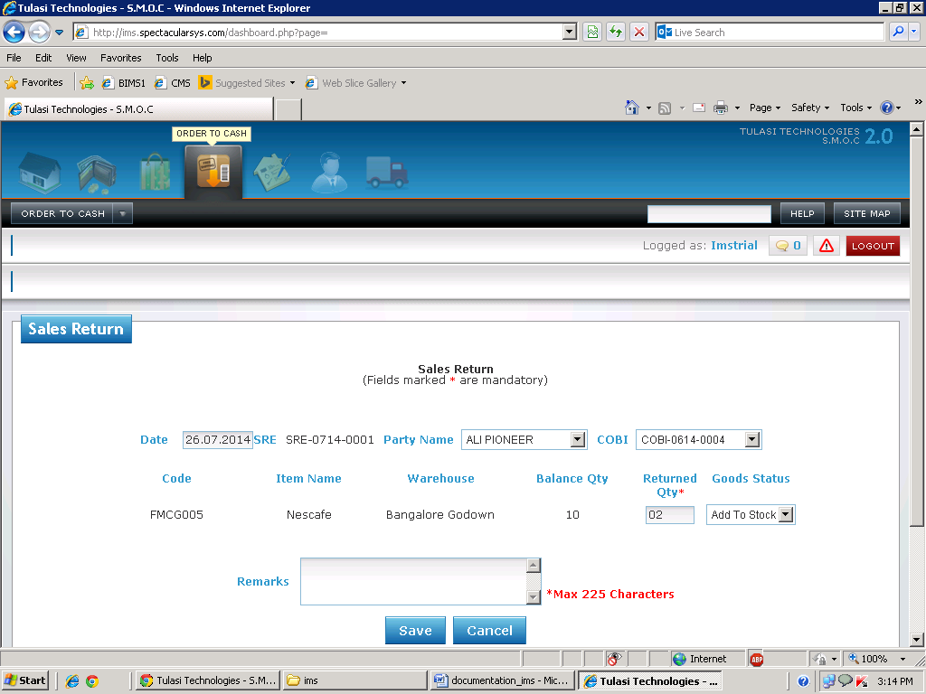

Basic Functionality:

1. This form is used for items which are return from the vendor..

2. Here you need to select the Party name. After you need select the COBI.

3. You need to select date.

4. Based on COBI corresponding item codes and how much quantity you sold information has to display.. Here you can enter how much quantity you want to return.

5. Here you select if you want to add the return quantity in stock or you can select as wastage.

Financial Impact:

|  |  |  |  |  |  |  |  |  |
| --- | --- | --- | --- | --- | --- | --- | --- | --- |
| Item code | Crdr | Coa code | Quantity | Amount | Trnum | Type | Venname | Warehouse |
| FMCG005 | Dr | AS113 | 2 | 17821.92 | SRE-0714-0001 | SRE | ALI PIONEER | Bangalore Godown |
| FMCG005 | Cr | CG116 | 2 | 17821.92 | SRE-0714-0001 | SRE | ALI PIONEER | Bangalore Godown |
| FMCG005 | Dr | SR116 | 2 | 1600 | SRE-0714-0001 | SRE | ALI PIONEER | Bangalore Godown |
|  | Cr | AS121 | 2 | 1600 | SRE-0714-0001 | SRE | ALI PIONEER | Bangalore Godown |

Effecting Tables:

* ac_financialpostings.
* Oc_Salesreturn.

Payment:

Screen Shot:

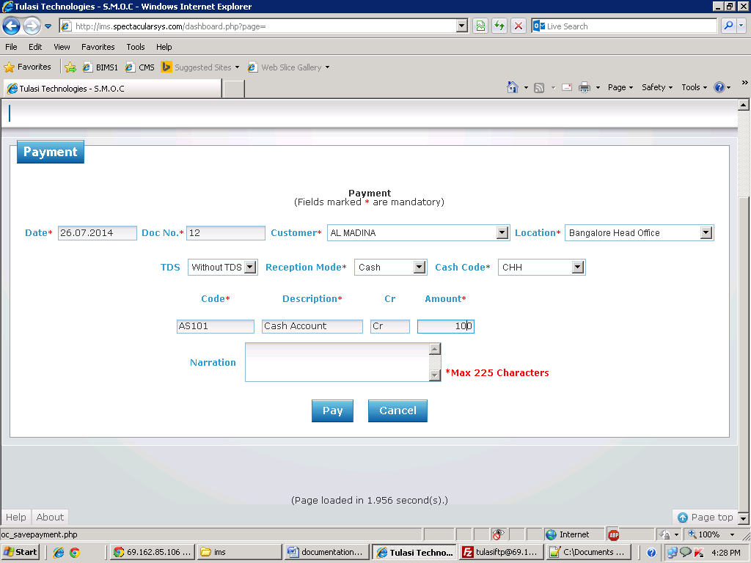

Basic Functionality:

1. This form is used for giving the payment to the Customer..

2. Here you need to select the Customer. After you need to which location you are paying the amount.

3. You need to select date and payment mode.

4. If you select cash then cash codes has to be loaded and if you select cash or transfer A/C no’s has to be loaded.

5. On selection of cash code or A/C no’s corresponding coacode and description will come automatically.

6. After enter amount to pay to the customer.

7. Here if you select TDS dynamic row will generate.

Financial Impact:

|  |  |  |  |  |  |  |  |  |
| --- | --- | --- | --- | --- | --- | --- | --- | --- |
| Item code | Crdr | Coa code | Quantity | Amount | Trnum | Type | Venname | Warehouse |
|  | Cr | AS101 | 0 | 100 | |  | | --- | | 5 | | OCPMT | Al Madina | Bangalore Head Office |
|  | Dr | AS121 | 0 | 100 | 5 | OCPMT | Al Madina | Bangalore Head Office |

Effecting Tables:

* ac_financialpostings.
* oc_payment.

Receipt:

Screen Shot:

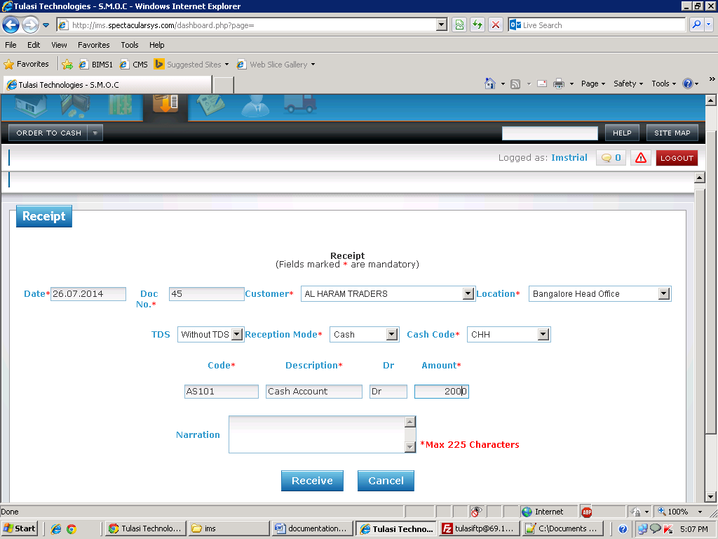

Basic Functionality:

1. This form is used for getting the amount from customer.

2. Here you need to select the customer. After you need to which location you are paying the amount.

3. You need to select date and payment mode.

4. If you select cash then cash codes has to be loaded and if you select cash or transfer A/C no’s has to be loaded.

5. On selection of cash code or A/C no’s corresponding coacode and description will come automatically.

6. After enter amount to pay to the customer.

7. Here if you select TDS dynamic row will generate.

Financial Impact:

|  |  |  |  |  |  |  |  |  |
| --- | --- | --- | --- | --- | --- | --- | --- | --- |
| Item code | Crdr | Coa code | Quantity | Amount | Trnum | Type | Venname | Warehouse |
|  | Dr | AS101 | 0 | 2000 | 36 | RCT | Al Haram Traders | Bangalore Head Office |
|  | Cr | LI111 | 0 | 2000 | 36 | RCT | Al Haram Traders | Bangalore Head Office |

Effecting Tables:

* ac_financialpostings.
* oc_receipt.

Credit Note:

Screen Shot:

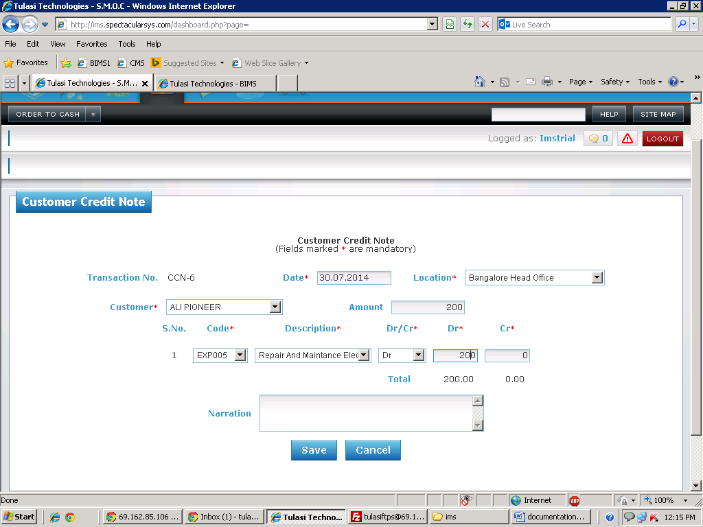

Basic Functionality:

1. This form is used for adjustments. It shows how much amount you need to pay the customer.

2. Here you need to select the customer. After you need to select location.

3. You need to select date and enter how much amount to adjust.

4. You need to select the code and description. Here the difference between sum of amounts of credit and debits should be equal to the amount

Financial Impact:

|  |  |  |  |  |  |  |  |  |
| --- | --- | --- | --- | --- | --- | --- | --- | --- |
| Item code | Crdr | Coa code | Quantity | Amount | Trnum | Type | Venname | Warehouse |
|  | Dr | EXP005 |  | 200 | CCN-6 | CCN | Ali Pioneer | Bangalore Head Office |
|  | Cr | AS121 |  | 200 | CCN-6 | CCN | Ali Pioneer | Bangalore Head Office |

Effecting Tables:

* ac_financialpostings.
* ac_crdrnote.

Debit Note:

Screen Shot:

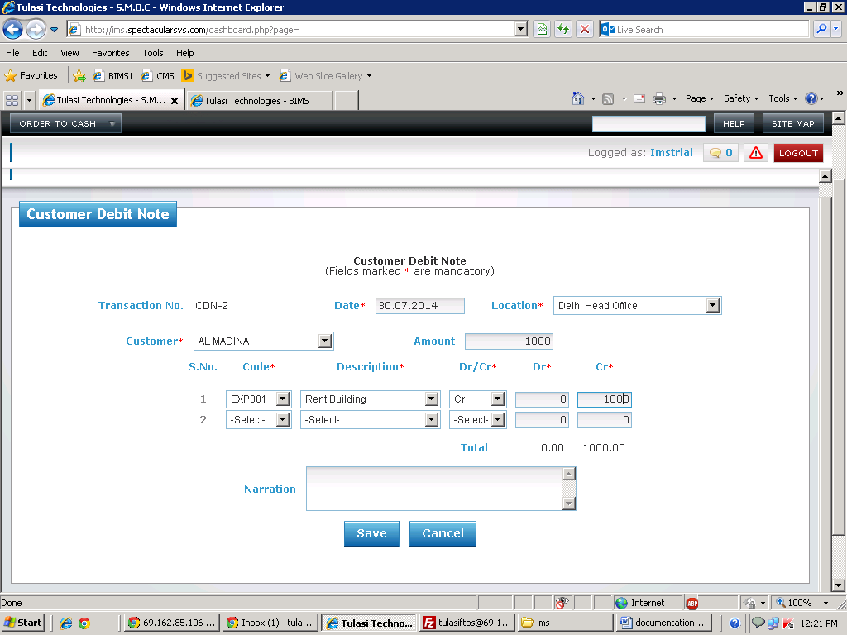

Basic Functionality:

1. This form is used for adjustments. It is used for how much amount you need get from customer.

2. Here you need to select the customer. After you need to select from which location you are getting amount.

3. You need to select date and enter how much amount to adjust.

4. You need to select the code and description. Here the difference between sum of amounts of credit and debits should be equal to the amount

Financial Impact:

|  |  |  |  |  |  |  |  |  |
| --- | --- | --- | --- | --- | --- | --- | --- | --- |
| Item code | Crdr | Coa code | Quantity | Amount | Trnum | Type | Venname | Warehouse |
|  | Dr | AS121 |  | 1000 | CDN-2 | CDN | Al Madina | Delhi Head Office |
|  | Cr | EXP001 |  | 1000 | CDN-2 | CDN | Al Madina | Delhi Head Office |

Effecting Tables:

* ac_financialpostings.
* ac_crdrnote.

**Inventory**

**Masters**

Item Master:

Screen Shot:

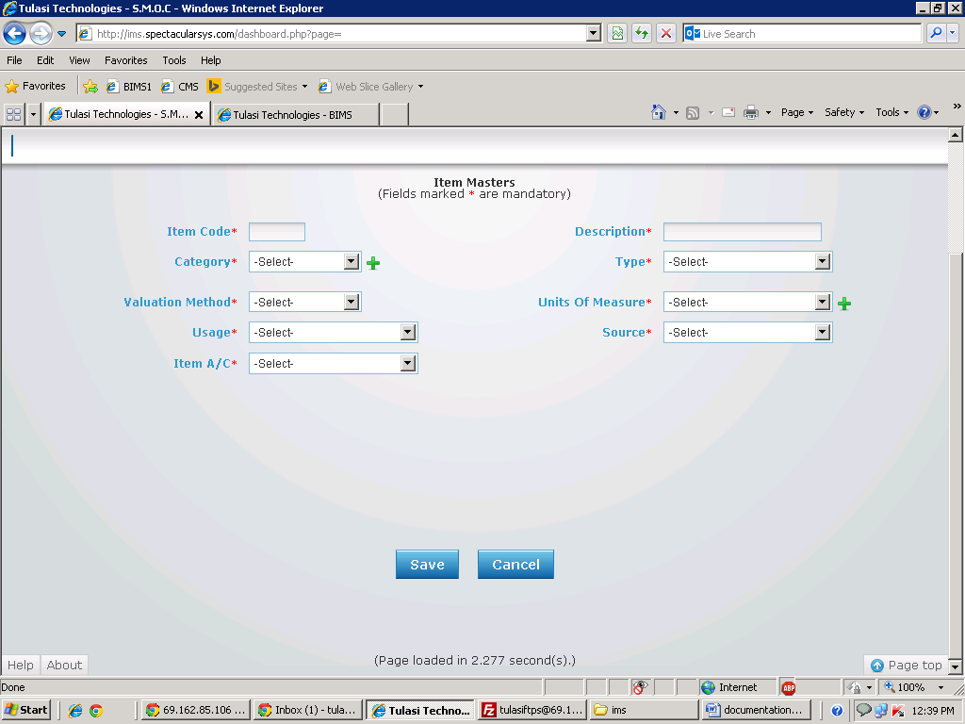

Basic Functionality:

1. This form is used to create item code. For this you have to enter item code and description.

2. After you have select the item has to from which category If required category is not there means select ‘+’ symbol then you will go to item category master.

3. After you need to select type. After you need to select valuation method, usage, source (Note: These all select boxes are hot coded).

4. Select unit of measure if the required unit of measure is not there means you can add by select ‘+’ button. Then you will redirect to unit of measure.

5. If valuation method is standard cost you will get a text box. There you can enter standard cost. Otherwise it is hidden

6. If the Usage is sale means you have to select sales A/C, COG A/C, Sales Return A/c. These accounts will come from ac_Coa

7. After you need to select item a/c. These accounts will come from ac_Coa

Effecting Tables:

* ims_itemcodes.

Location Masters:

Screen Shot:

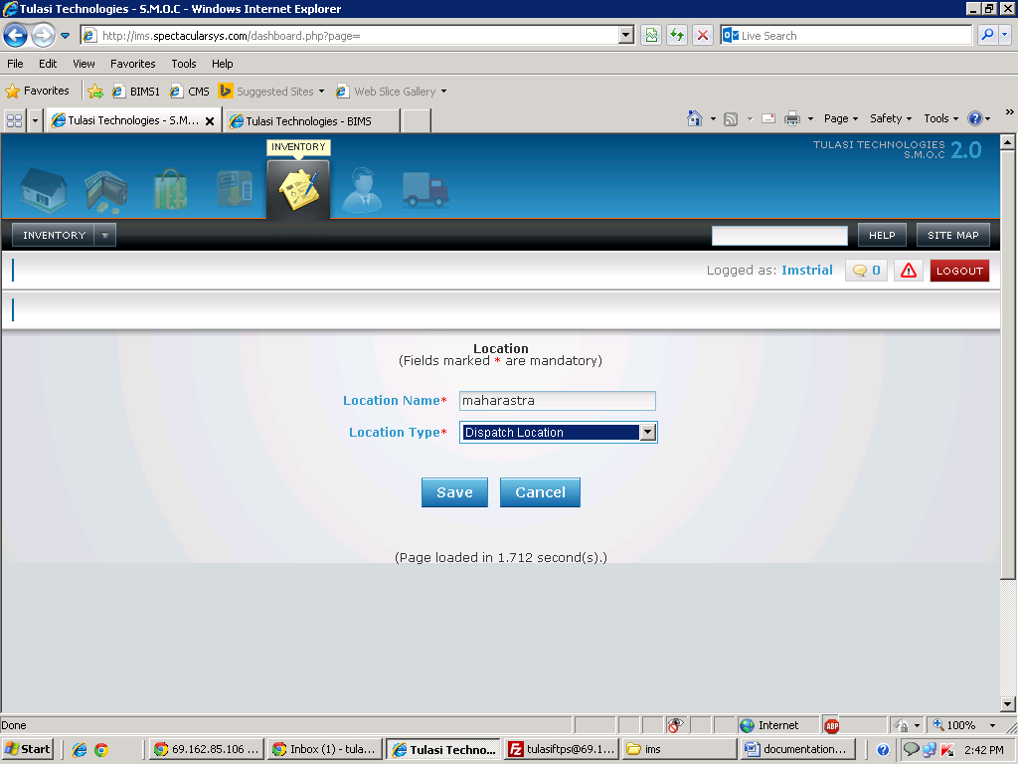

Basic Functionality:

1. This form is used to create the sectors.

2. Here first we have to enter the Location name

Effecting Tables:

* tbl_Sector

Item Category:

Screen Shot:

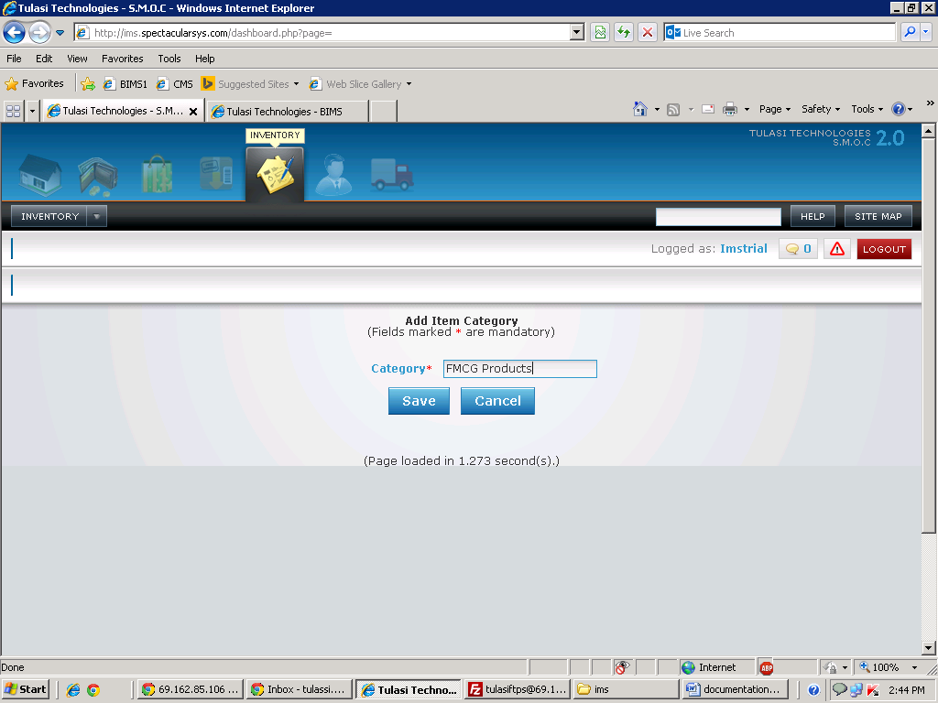

Basic Functionality:

1. This form is used to create the item category.

2. Here you can enter item category

Effecting Tables:

* ims_itemtypes.

Stock Transfer:

Screen Shot:

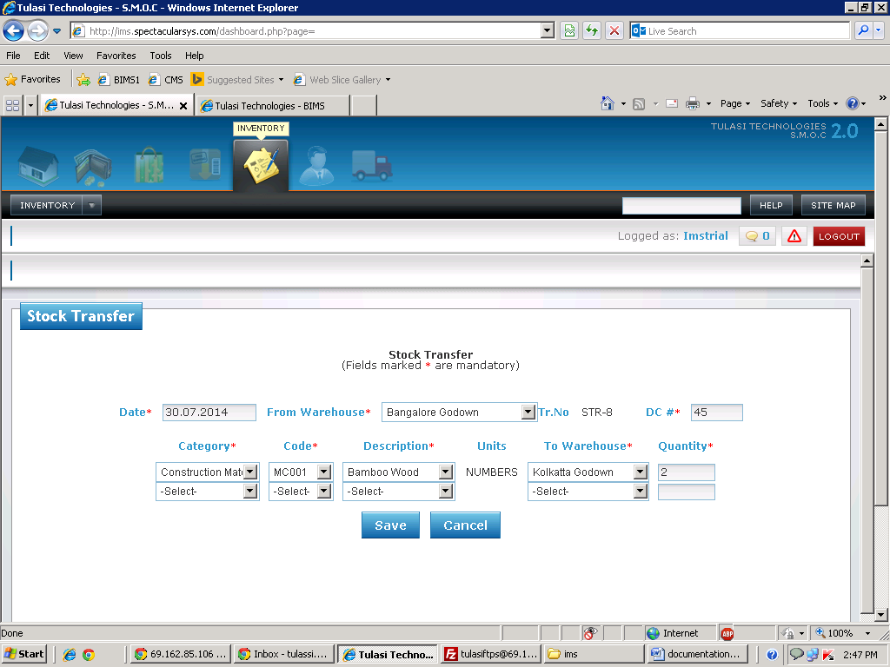

Basic Functionality:

1. This form is used for things which are transferred from one warehouse to another warehouse.

2. Here you need to select the Warehouse. After you need to enter delivery challan no.

3. After you need select the category. You will get corresponding item codes for of that selected category. Then you need to select to which warehouse you are transferring

4. Here you have to enter how much quantity you are transferring.

(Note: Here price will calculate based on calculation method).

5. Stock checks also available. i.e you are trying to transfer excess quantity which are not available in you godown, it will show alert and entry should not save.

Financial Impact:

|  |  |  |  |  |  |  |  |  |
| --- | --- | --- | --- | --- | --- | --- | --- | --- |
| Item code | Crdr | Coa code | Quantity | Amount | Trnum | Type | Venname | Warehouse |
| MC001 | Dr | AS112 | 2 | 20.88 | 32 | STR |  | Kolkatta Godown |
| MC001 | Cr | AS112 | 2 | 20.88 | 32 | STR |  | Kolkatta Godown |

Effecting Tables:

* ac_financialpostings.
* Ims_stocktransfer.

Stock Adjustment :

Screen Shot:

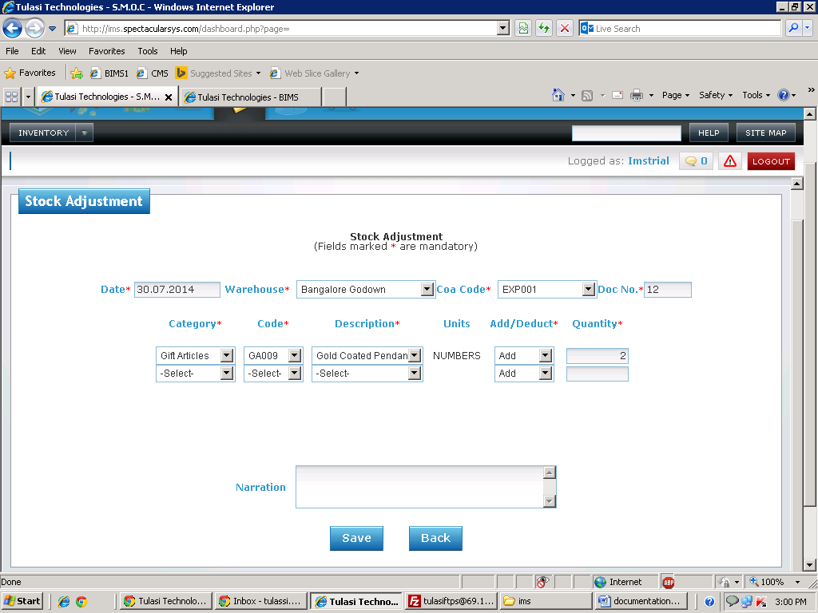

Basic Functionality:

1. This form is used for things which you want to adjust the stock.

2. Here you need to select the Warehouse and coacode. After you need to enter document number

3. After you need select the category. You will get corresponding item codes for of that selected category. Then you need to select to add the quantity or deduct the quantity.

4. Here you have to enter how much quantity you want to adjust.

(Note: Here price will calculate based on calculation method).

5. Stock checks also available if you want to deduct the itemcode . i.e you are trying to transfer excess quantity which are not available in you godown, it will show alert and entry should not save.

Financial Impact:

|  |  |  |  |  |  |  |  |  |
| --- | --- | --- | --- | --- | --- | --- | --- | --- |
| Item code | Crdr | Coa code | Quantity | Amount | Trnum | Type | Venname | Warehouse |
| GA009 | Dr | AS117 | 2 | 2148.64 | 5 | STA | Bangalore Godown | Bangalore Godown |
| GA009 | Cr | EXP001 | 2 | 2148.64 | 5 | STA | Bangalore Godown | Bangalore Godown |

Effecting Tables:

* ac_financialpostings.
* Ims_stockadjustment

Intermediate Receipt :

Screen Shot:

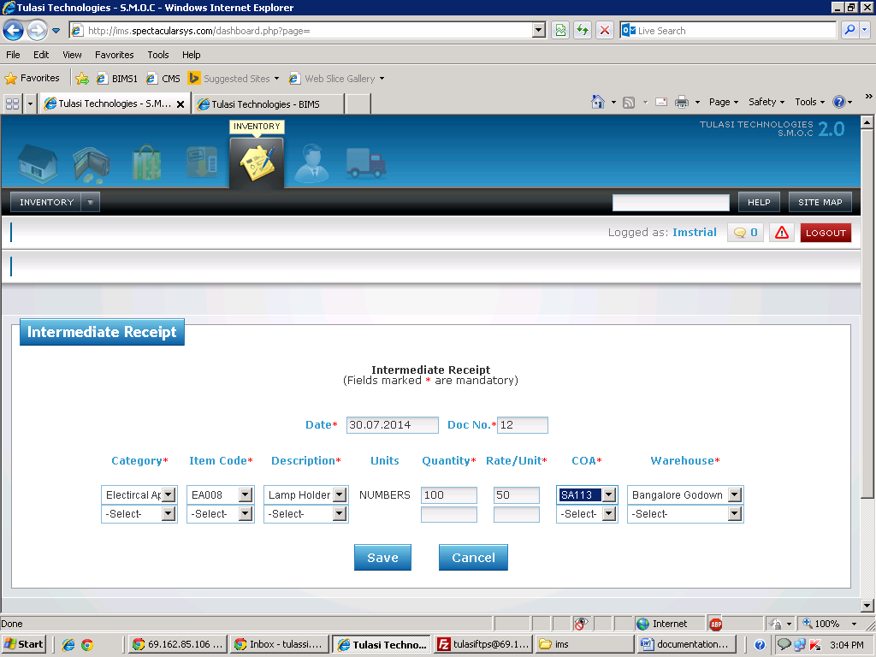

Basic Functionality:

1. This form is used for things which you received stock.

2. Here need to enter document number

3. After you need select the category. You will get corresponding item codes for of that selected After select warehouse

4. Here you have to enter how much quantity you received. Enter the price of item.

Financial Impact:

|  |  |  |  |  |  |  |  |  |
| --- | --- | --- | --- | --- | --- | --- | --- | --- |
| Item code | Crdr | Coa code | Quantity | Amount | Trnum | Type | Venname | Warehouse |
| EA008 | Dr | AS114 | 100 | 5000 | 15 | IR | Bangalore Godown | Bangalore Godown |
| EA008 | Cr | SA113 | 100 | 5000 | 15 | IR | Bangalore Godown | Bangalore Godown |

Effecting Tables:

* ac_financialpostings.
* Ims_intermediaterecipt

Intermediate Issue :

Screen Shot:

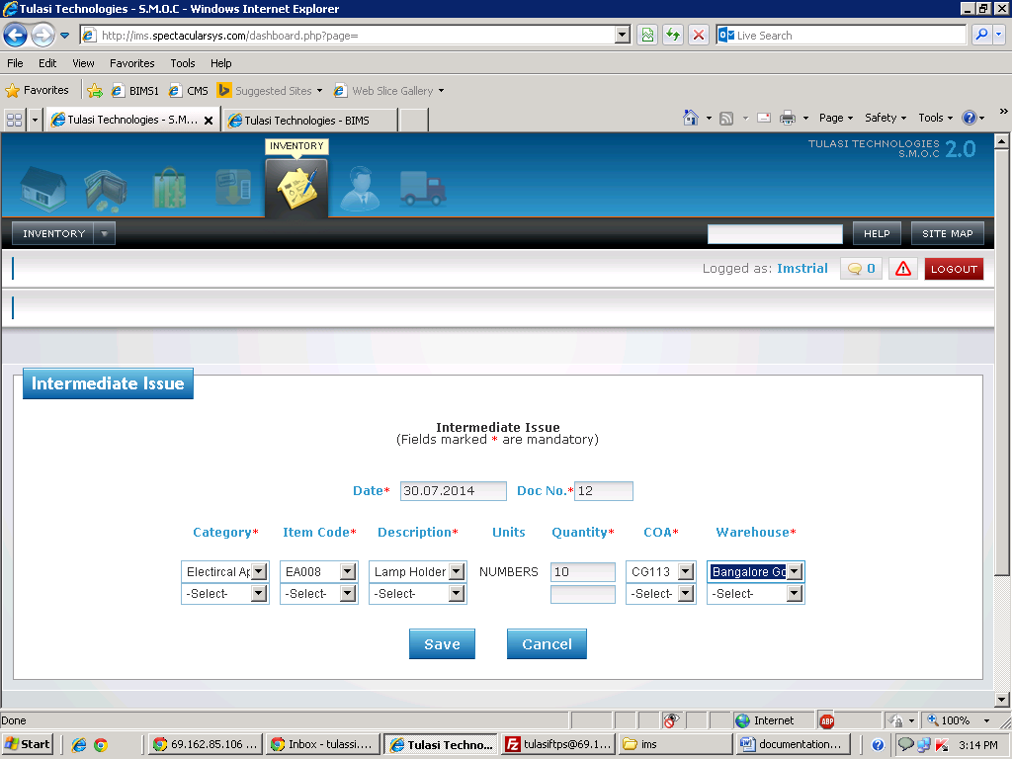

Basic Functionality:

1. This form is used for issuing stock.

2. You need to enter document number

3. After you need select the category. You will get corresponding item codes for of that selected category. Then you need to enter how much quantity you want to issue.

4. Here you have to select coacode and warehouse.

(Note: Here price will calculate based on calculation method).

5. Stock checks also available. i.e you are trying to issue excess quantity which are not available in you godown, it will show alert and entry should not save.

Financial Impact:

|  |  |  |  |  |  |  |  |  |
| --- | --- | --- | --- | --- | --- | --- | --- | --- |
| Item code | Crdr | Coa code | Quantity | Amount | Trnum | Type | Venname | Warehouse |
| EA008 | Cr | AS114 | 10 | 337.6 | 2 | II | Bangalore Godown | Bangalore Godown |
| EA008 | Dr | CG113 | 10 | 337.6 | 2 | II | Bangalore Godown | Bangalore Godown |

Effecting Tables:

* ac_financialpostings.
* Ims_intermediaterecipt

**Human Resources**

**Masters**

Create Employee:

Screen Shot,

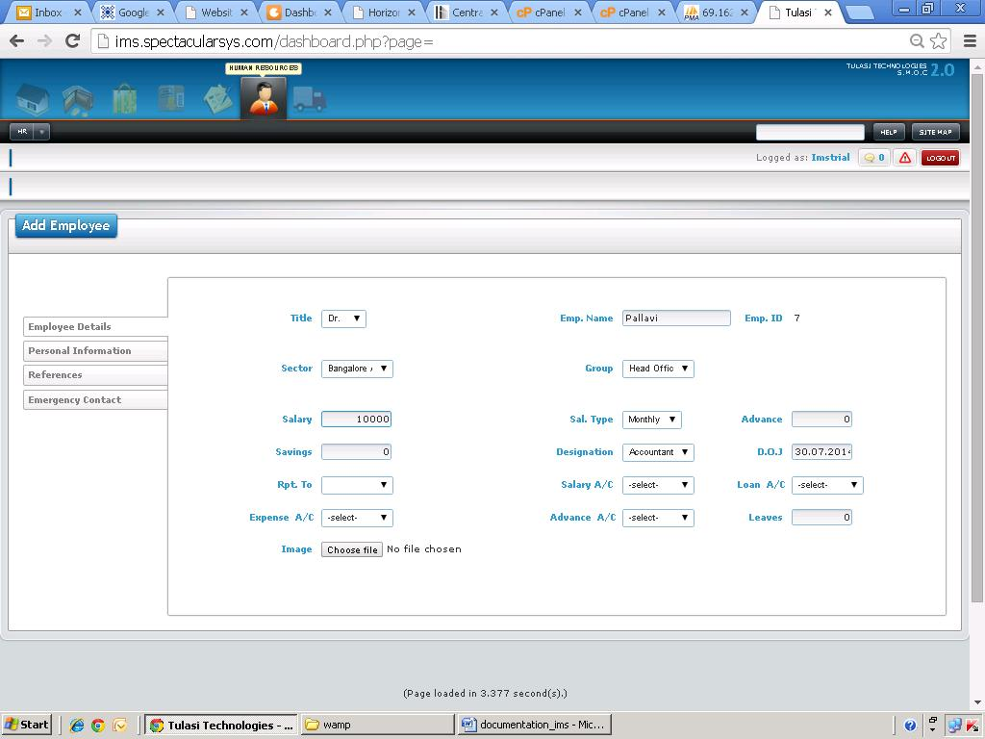

Basic Functionality:

1.This form is used to create a employee record.

Effecting Tables:

* hr_employee

**Holiday Masters:**

Screen shot:

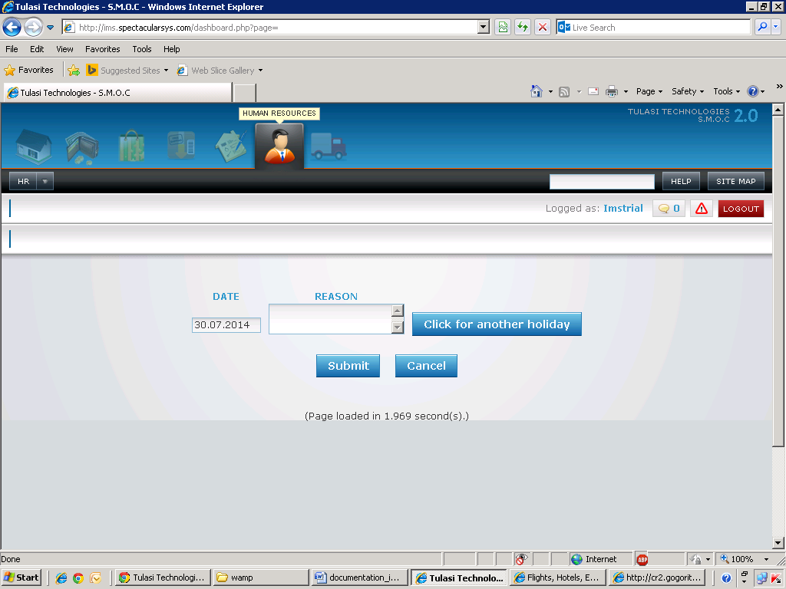

Basic Functionality:

1.To keep record of holidays

Effecting tables:

* hr_holidays

**Define Parameters:**

Screen shot:

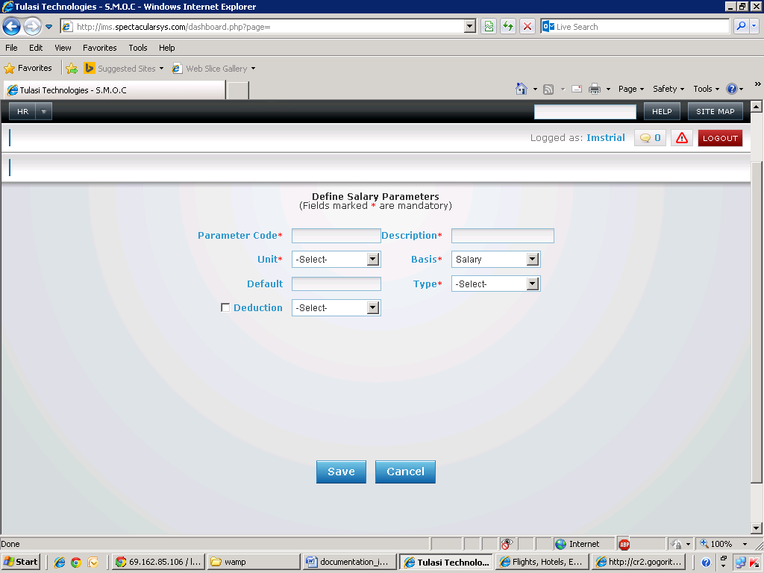

Basic Functionality:

1. Used to create a salary parameter for a particular unit on basis of salary or other aspects

Effecting tables:

* hr_params

**Professional Tax**

Screen shot:

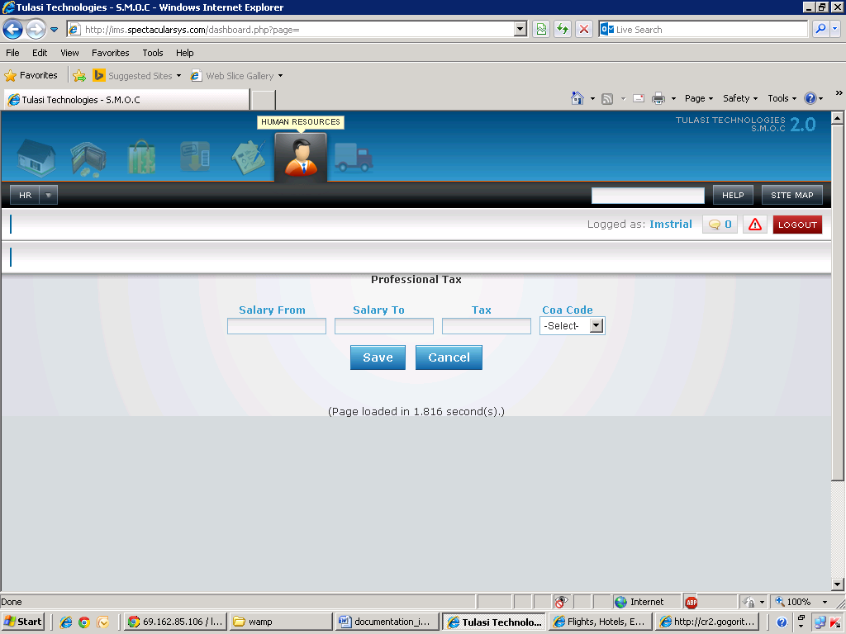

Basic Functionality:

1. To record professional tax value for a particular salary range along with the effecting coa code.

Effecting tables:

* hr_pf

**Working Days**

Screen shot:

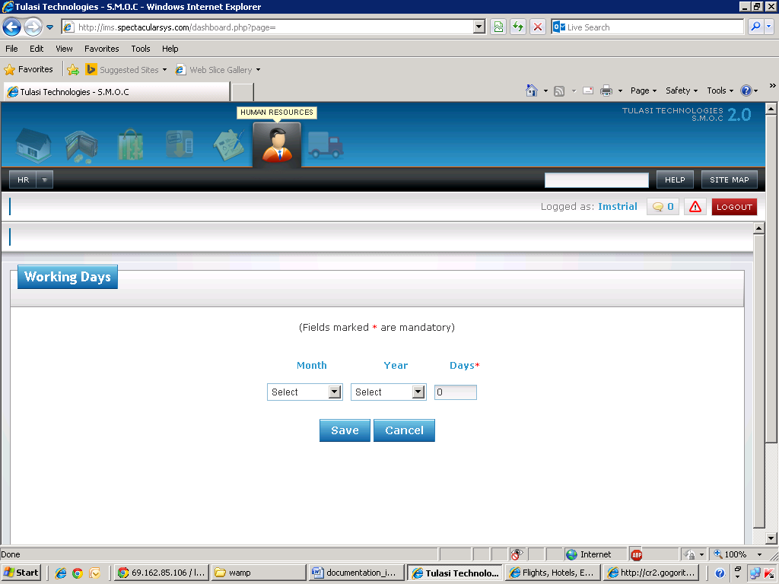

Basic functionality:

1. To record number of working days of a particular month for a particular year.

Effecting tables :

* hr_working_days

Leaves Allowed

Screen shot:

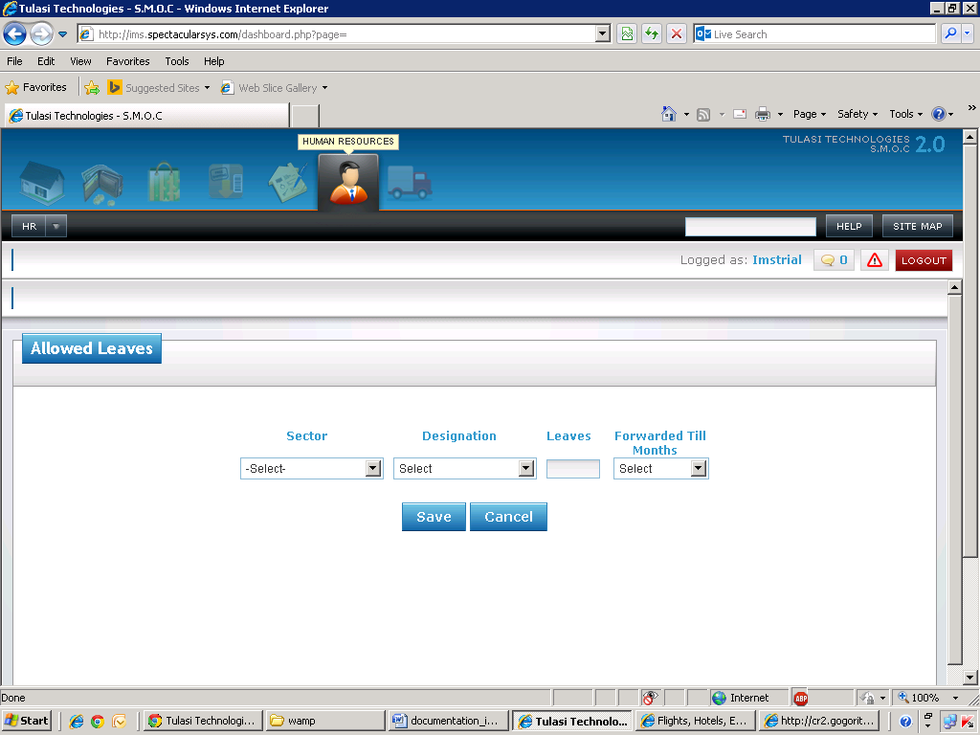

Basic Functionality:

1. To keep track of leaves allowed for a particular section and designation

Effecting tables:

* hr_mnthleaves

Define Salary Procedure

Screen shot:

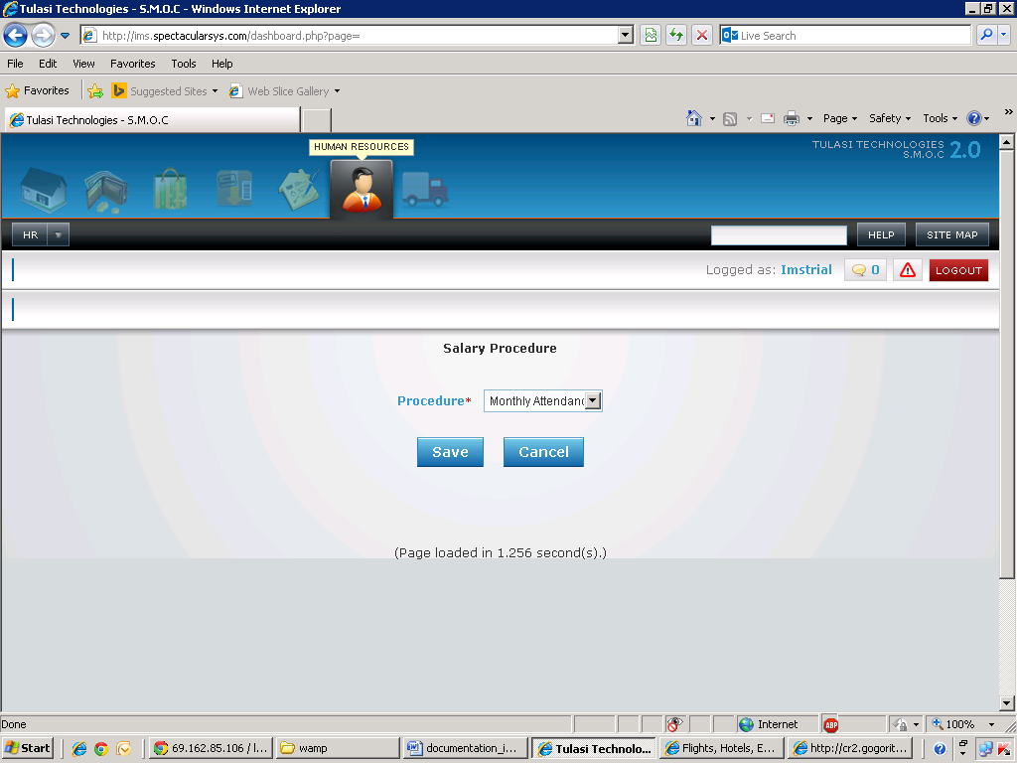

Basic Functionality

1.To decide whether salary procedure is based on monthly attendance or salary

Effecting tables:

* hr_salary_procedure

Create Designation:

Screen shot:

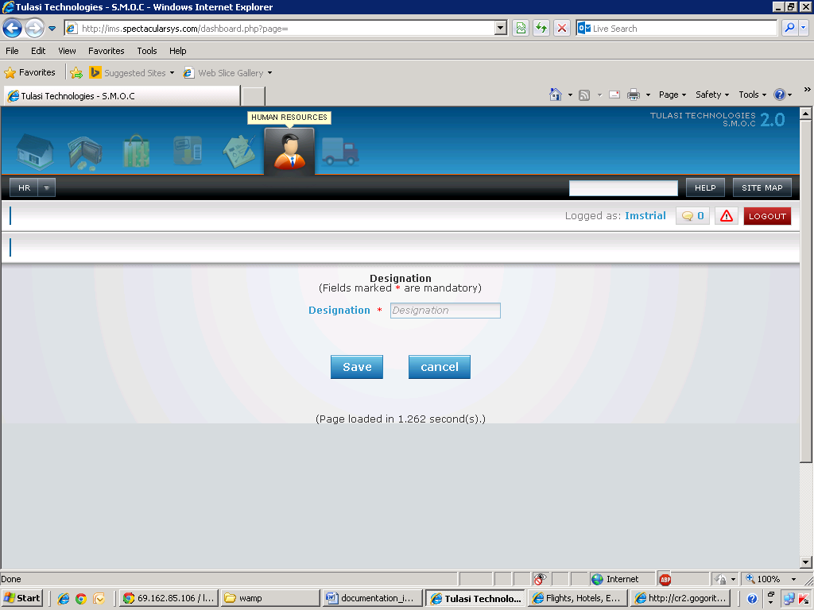

Basic Functionality:

1.To create a new designation

Effecting tables:

* hr_designation

Income Tax

Screen shot:

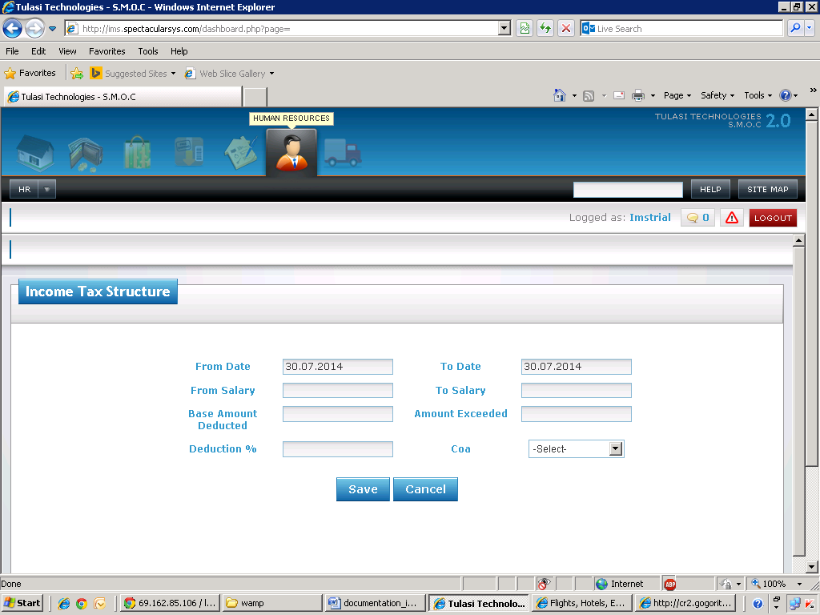

Basic Functionality:

1.To record income tax structure for a particular salary range for a specific period of time.

Effecting tables:

* hr_incometax

Transactions

Attendance:

Screen Shot:

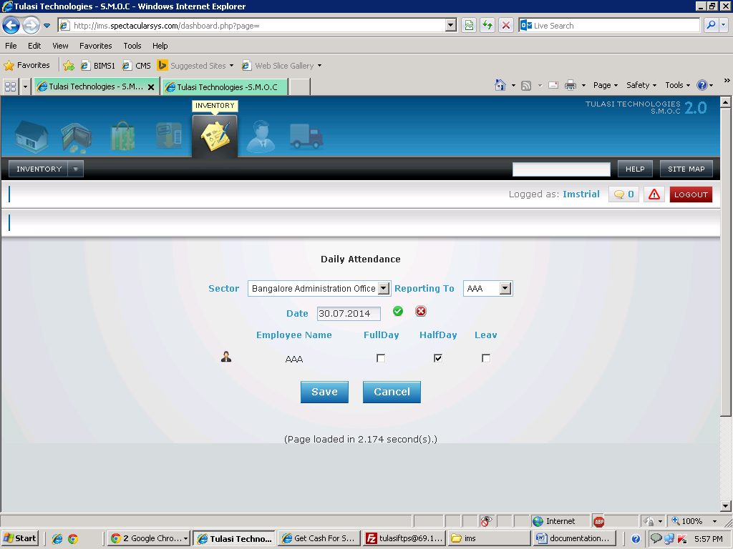

Basic Functionality:

1. This form is used to enter daily attendance. If the salary procedure defined as daily attendance then you have to enter the details

Effecting Tables:

* Hr_attendance

Monthly Attendance:

Screen Shot:

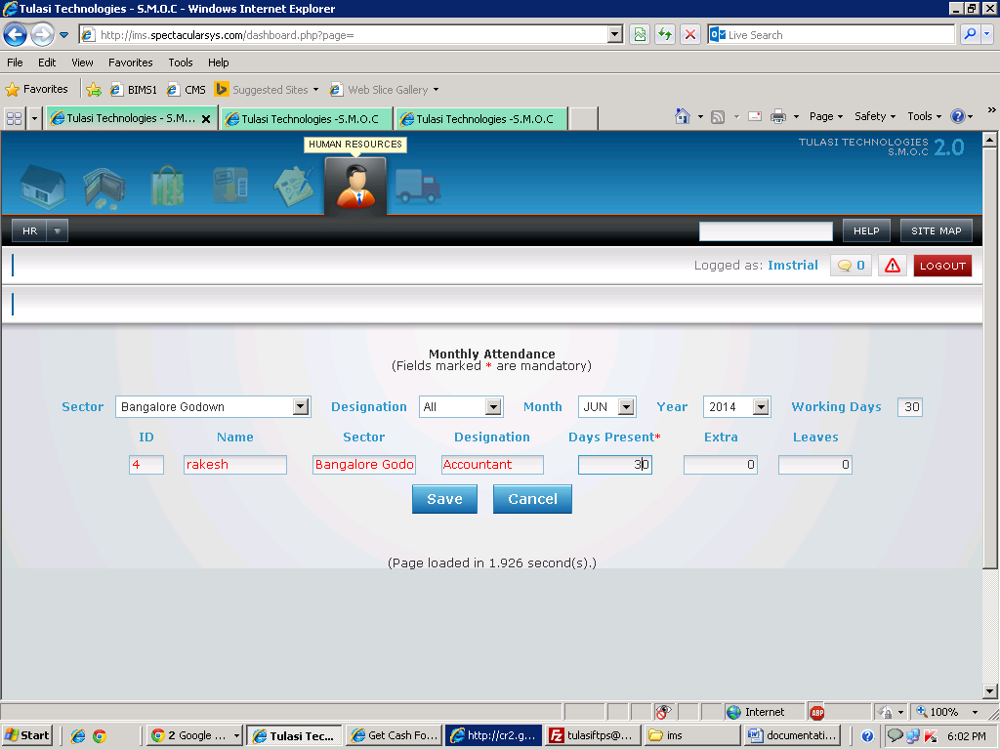

Basic Functionality:

1. This form is used to enter monthly attendance. If the salary procedure defined as monthly attendance then you have to enter the details

2. On selection of sector, designation will come and based on month and year, it will show working days from hr_workingdays

3. After you have to enter how many days he worked

Effecting Tables:

* Hr_mnth_attendance

Salary Parameters:

Screen Shot:

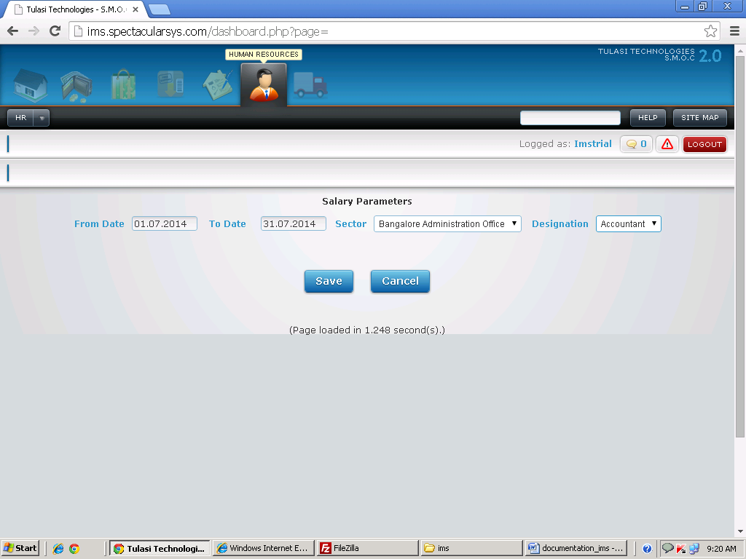

Basic Functionality:

1. This form is used to enter salary parameters between from date and to date. If salary parameter is not there means in salary generation employee salary will show as zero even working days also available.

2. On selection of sector, designation will load.

Effecting Tables:

* Hr_salary_parameters

Processing

Salary Generation:

Screen Shot:

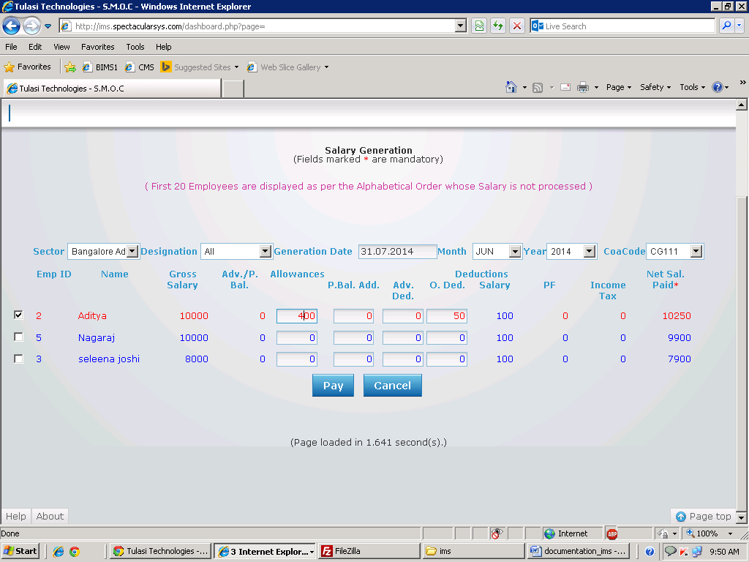

Basic Functionality:

1. This form is used to generate salary for employees.
2. On selection of sector, designation will come. Based on designation, month and year it will check weather define params (masters), salary parameters(transaction),working days, monthly attendance it will check. If all are available only salary generation of employee will come.
3. While creating employee if any advance are there it will show. If any allowances there means you can enter.
4. Here you need to select the checkboxes. To which employee you are selecting for those employees only salary generation will happen.

Financial Impact:

|  |  |  |  |  |  |  |  |  |
| --- | --- | --- | --- | --- | --- | --- | --- | --- |
| Item code | Crdr | Coa code | Quantity | Amount | Trnum | Type | Venname | Warehouse |
|  | Cr | EXP001 |  | 100 | 2 | Empgen | Aditya | Bangalore Administration Office |
|  | Cr | CG112 |  | 10250 | 2 | Empgen | Aditya | Bangalore Administration Office |
|  | Dr | CG111 |  | 10350 | 2 | Empgen | Aditya | Bangalore Administration Office |

Effecting Tables:

* Hr_salary_generation
* Ac_financialpostings

Salary Payment:

Screen Shot:

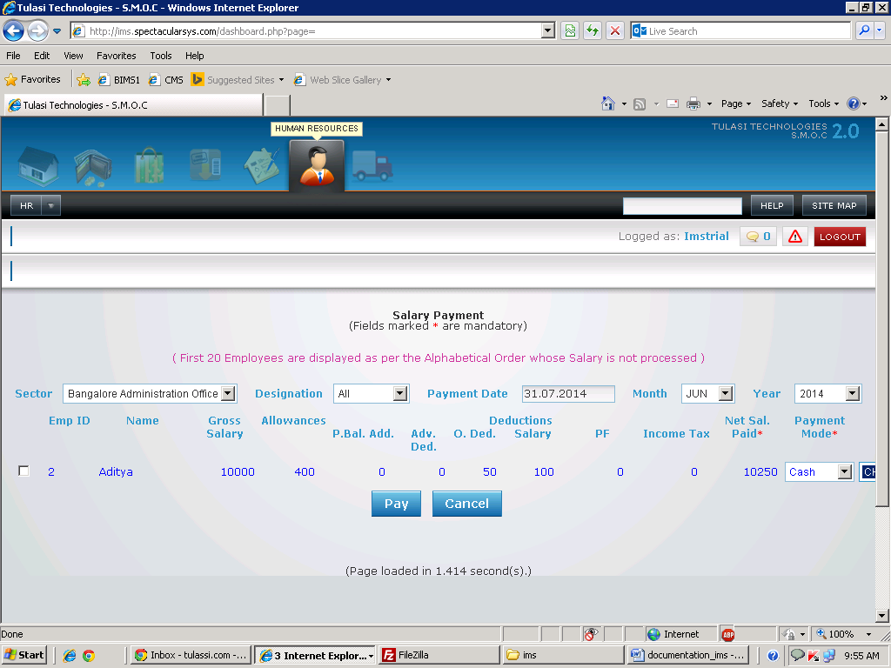

Basic Functionality:

1. This form is used to pay salary for employees.
2. On selection of sector, designation will come. Based on designation, month and year it will check weather salary generation is available or not. If it is there and salary not paid then it will display the employee record.
3. Here you need to select the checkboxes. To which employee you want to pay select the check box.
4. You need to select you are paying through which mode and select coacode.

Financial Impact:

|  |  |  |  |  |  |  |  |  |
| --- | --- | --- | --- | --- | --- | --- | --- | --- |
| Item code | Crdr | Coa code | Quantity | Amount | Trnum | Type | Venname | Warehouse |
|  | Cr | AS131 |  | 10250 | 2 | EMPSAL | Aditya | Bangalore Administration Office |
|  | Dr | CG112 |  | 10250 | 2 | EMPSAL | Aditya | Bangalore Administration Office |

Effecting Tables:

* Hr_salary_generation
* Ac_financialpostings
* Hr_salary_payment

Employee Credit Note:

Screen Shot:

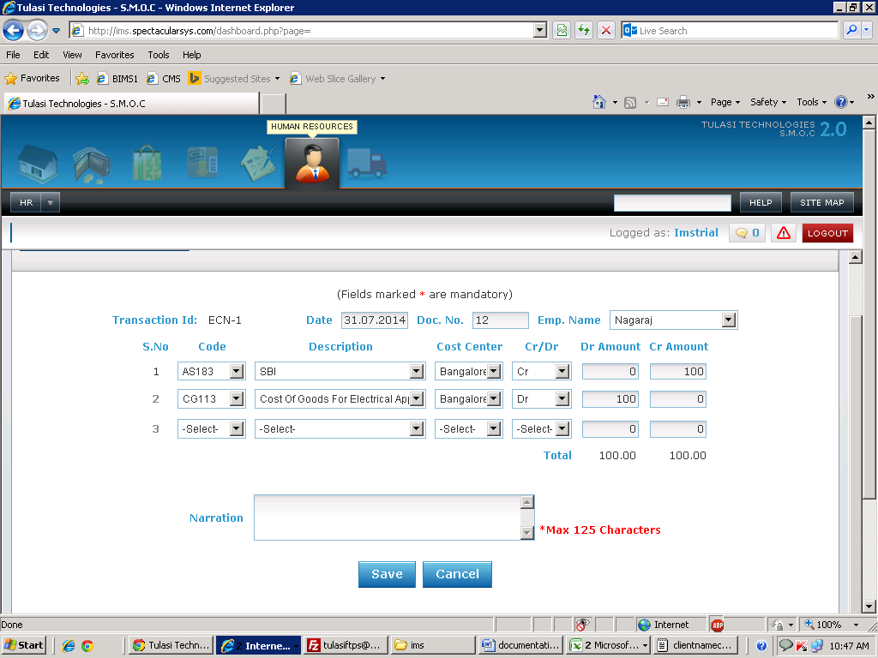

Basic Functionality:

1. This form is used for employee credit note.
2. For a particular employee the amount to be credited along with the respective debiting coacode can be selected here.
3. The form will save only debit amount is equal to the credit amount.

Financial Impact:

|  |  |  |  |  |  |  |  |  |
| --- | --- | --- | --- | --- | --- | --- | --- | --- |
| Item code | Crdr | Coa code | Quantity | Amount | Trnum | Type | Venname | Warehouse |
|  | Dr | CG113 |  | 100 | ECN-1 | Credit | Nagaraj | Bangalore Administration Office |
|  | Cr | AS183 |  | 100 | ECN-1 | Credit | Nagaraj | Bangalore Administration Office |

Effecting Tables:

* Hr_empcrdrnote
* Ac_financialpostings

Employee Debit Note:

Screen Shot:

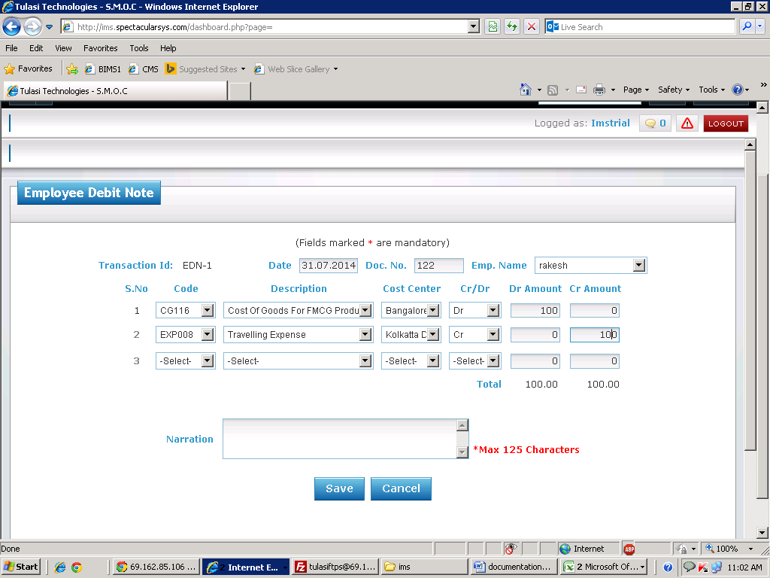

Basic Functionality:

1. This form is used for employee debit note.
2. For a particular employee the amount to be debited along with the respective crediting coacode can be selected here.
3. The form will save only debit amount is equal to the credit amount.

Financial Impact:

|  |  |  |  |  |  |  |  |  |
| --- | --- | --- | --- | --- | --- | --- | --- | --- |
| Item code | Crdr | Coa code | Quantity | Amount | Trnum | Type | Venname | Warehouse |
|  | Dr | CG116 |  | 100 | EDN-1 | Debit | rakesh | Bangalore Godown |
|  | Cr | EXP008 |  | 100 | EDN-1 | Debit | rakesh | Kolkatta Dispatch Location |

Effecting Tables:

* Hr_empcrdrnote
* Ac_financialpostings

Employee Payment Voucher:

Screen Shot:

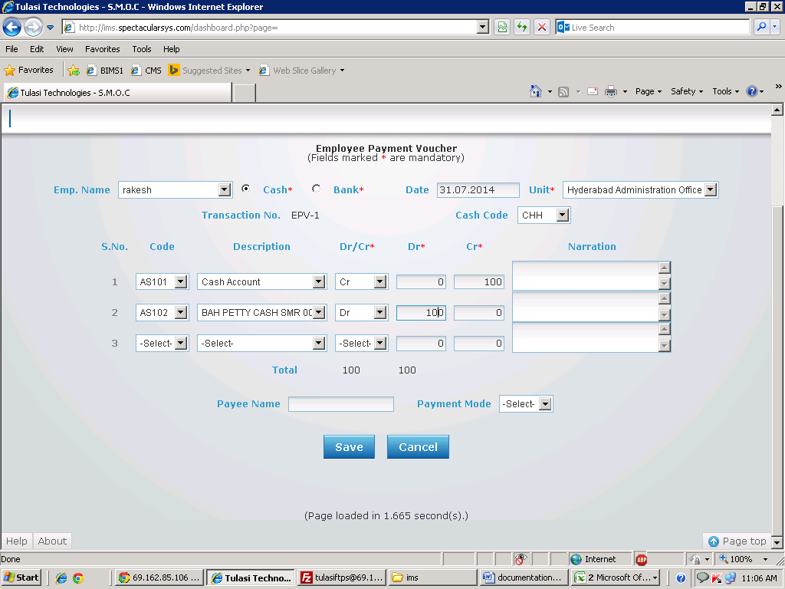

Basic Functionality:

1. This form is used for employee payment voucher.
2. For a particular employee the amount to be payment has to be done through cash or bank.
3. The form will save only debit amount is equal to the credit amount.

Financial Impact:

|  |  |  |  |  |  |  |  |  |
| --- | --- | --- | --- | --- | --- | --- | --- | --- |
| Item code | Crdr | Coa code | Quantity | Amount | Trnum | Type | Venname | Warehouse |
|  | Dr | AS102 |  | 100 | EPV-1 | EPV | Rakesh | Hyderabad Administration Office |
|  | Cr | AS101 |  | 100 | EPV-1 | EPV | Rakesh | Hyderabad Administration Office |

Effecting Tables:

* Hr_empcrdrnote
* Ac_financialpostings

**Vehicle Management**

**Masters**

Vehicle type:

Screen Shot:

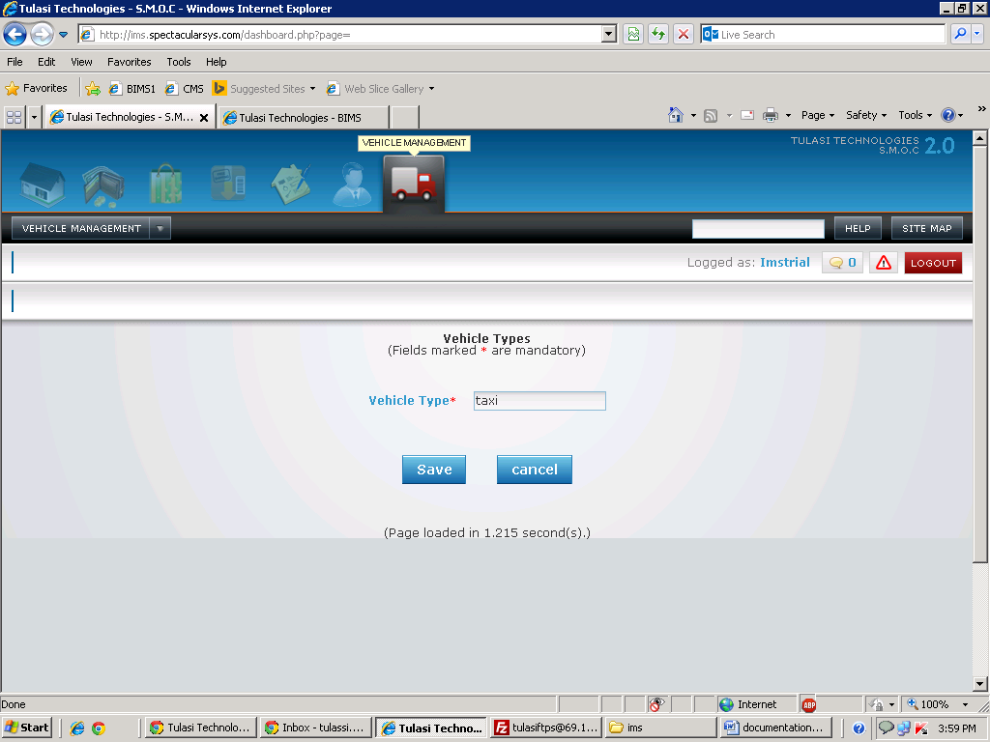

Basic Functionality:

1. This form is used to enter new vehicle type.

Effecting Tables:

* Vehicle_type

Vehicle master:

Screen Shot:

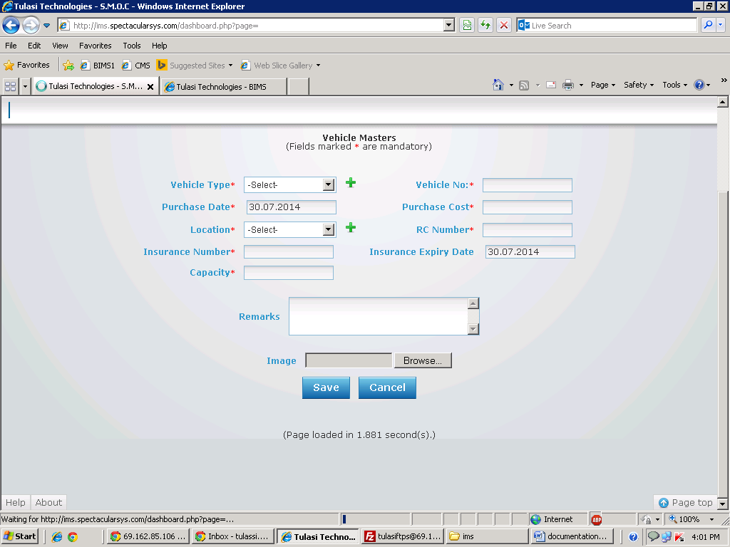

Basic Functionality:

1. This form is used for entering vehicle details.

2. You need to select vehicle type and location

3. After you need to enter vehicle number, purchase cost, insurance number, rc number, capacity and all basic details.

4. Here you want to add any vehicle type or location click on ‘+’ .There you can add.

Effecting Tables:

* Vehicle_master

Vehicle Spare Parts:

Screen Shot:

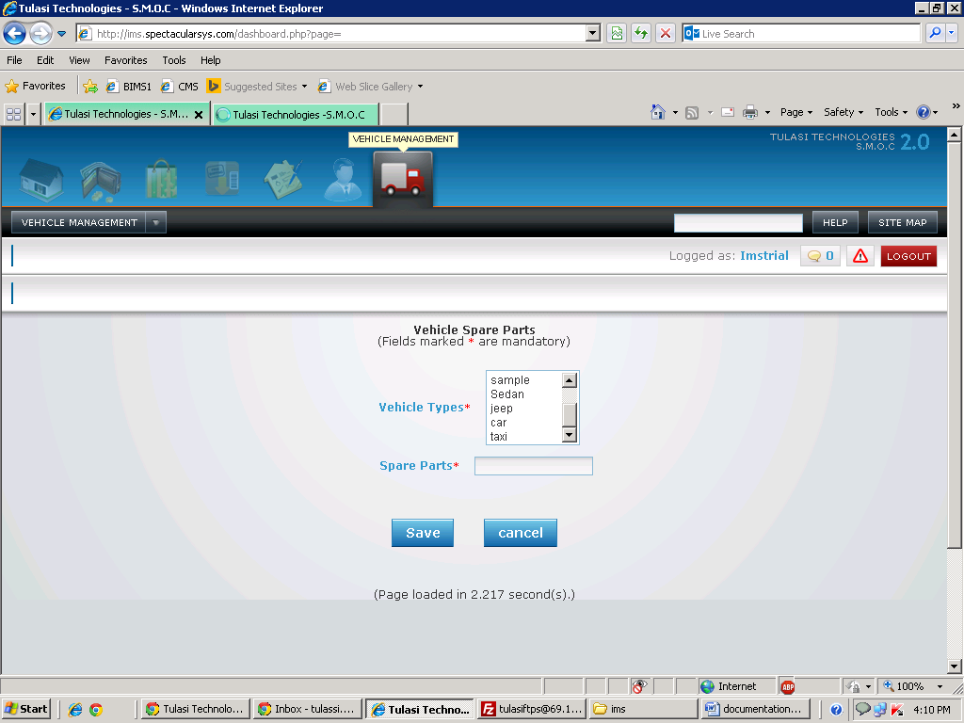

Basic Functionality:

1. This form is used for entering spare parts details.

2. You need to select vehicle type

3. After you need to enter spare parts.

Effecting Tables:

* Vehicle_master

Vehicle Service Master:

Screen Shot:

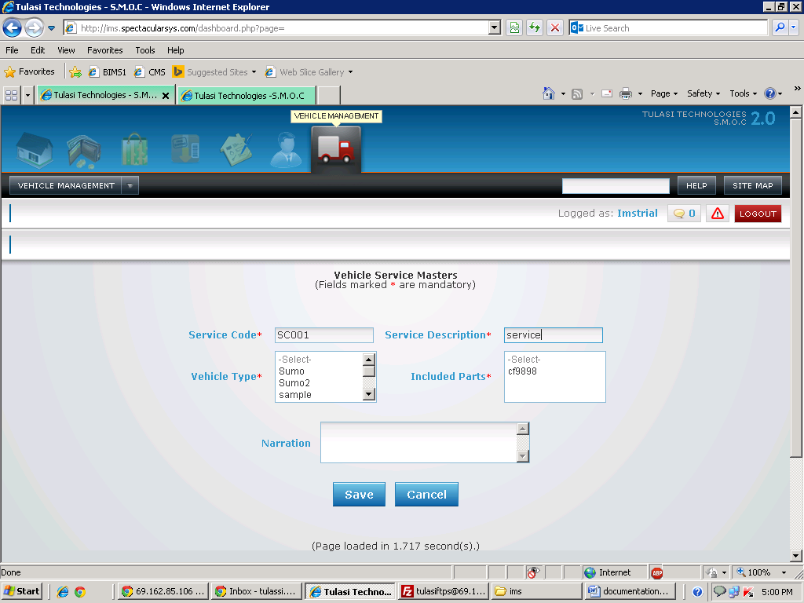

Basic Functionality:

1. This form is used for entering about vehicle service.

2. You need to select vehicle type and included parts

3. After you need to enter service code and service description.

Effecting Tables:

* Vehicle_servicemaster

Vehicle Charge Master:

Screen Shot:

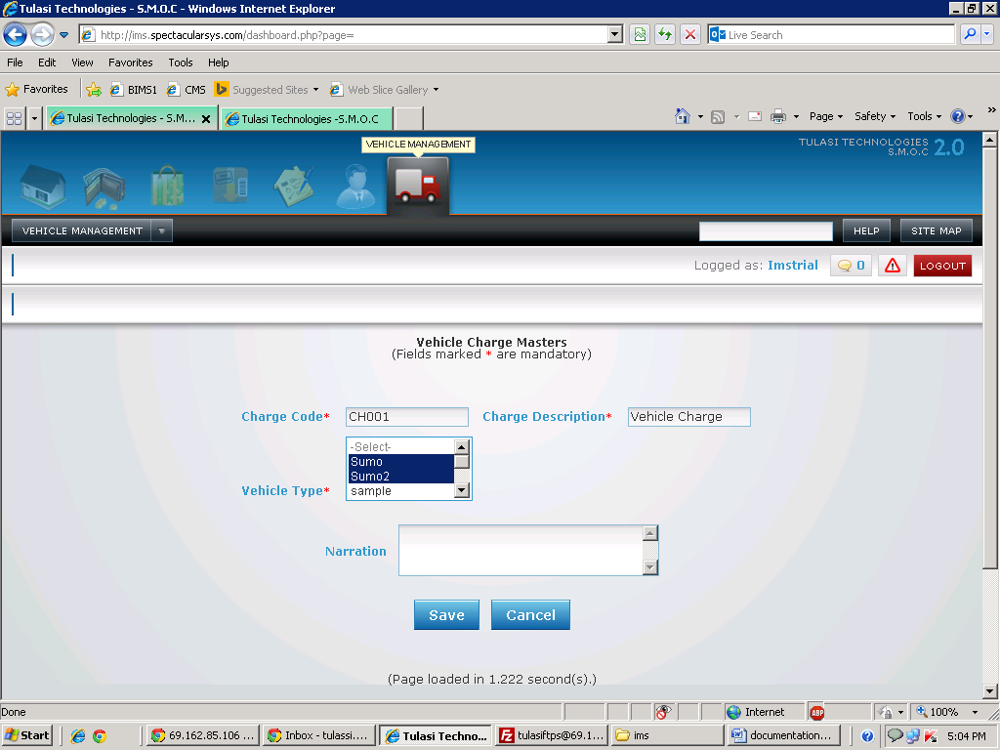

Basic Functionality:

1. This form is used for entering about charges.

2. You need to select vehicle type

3. After you need to enter charge code and charge description.

Effecting Tables:

* Vehicle_chargemaster

Transactions

Vehicle Trip Sheet:

Screen Shot:

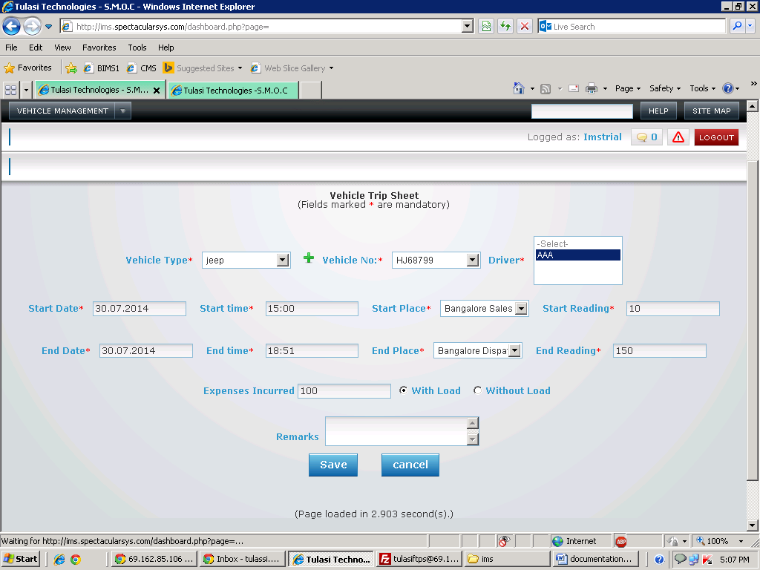

Basic Functionality:

1. This form is used for entering trip details.

2. You need to select vehicle type and driver

3. After you need to enter details like start date and time, end date and time, start reading ending reading, starting place and ending place and expenses incurred.

Effecting Tables:

* Vehicle_tripdetails

Vehicle Servicing:

Screen Shot:

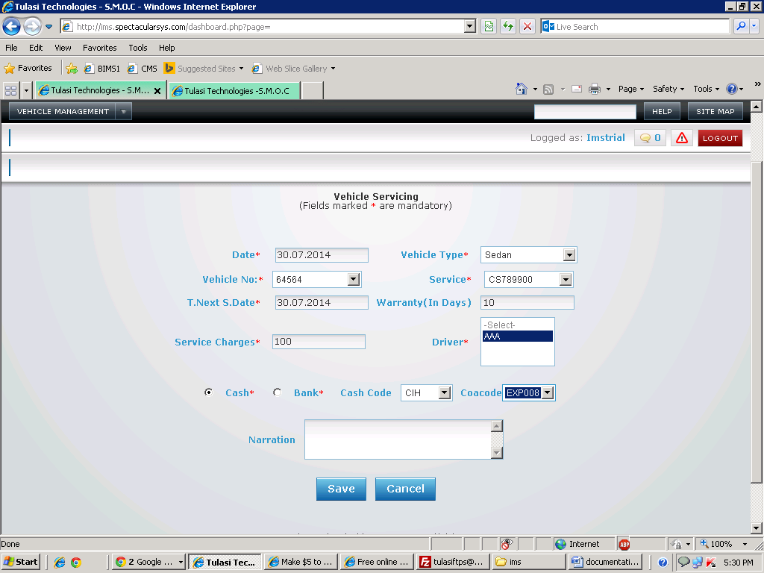

Basic Functionality:

1. This form is used for which vehicle services are done.

2. You need to select vehicle type, vehicle number and drive and service code

3. After you need to enter details like T.NextS.Date, warranty and service charges.

4. After you have to select cash/ bank through which you are paying.

5. Based on selection cash code or bank code will load. You have to select cash code and coacode.

Financial Impact:

|  |  |  |  |  |  |  |  |  |
| --- | --- | --- | --- | --- | --- | --- | --- | --- |
| Item code | Crdr | Coa code | Quantity | Amount | Trnum | Type | Venname | Warehouse |
|  | Cr | AS180 |  | 100 | VS-8 | VS | imstrial | Bangalore Sales Office |
|  | Dr | EXP008 |  | 100 | VS-8 | VS | imstrial | Bangalore Sales Office |

Effecting Tables:

* ac_financialpostings.
* Vehicle_Servicing

Vehicle Fuel Filling:

Screen Shot:

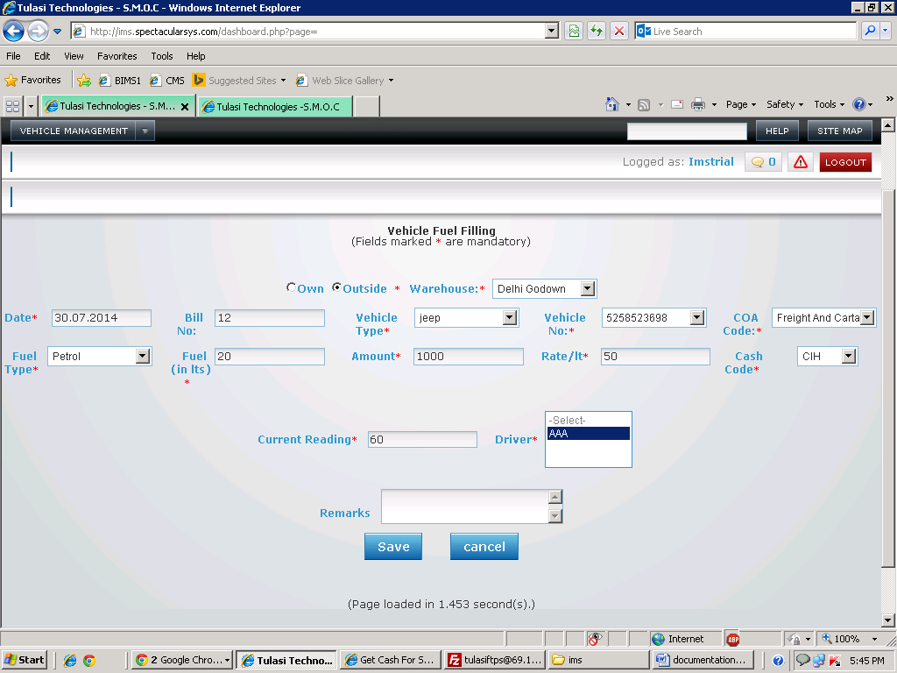

Basic Functionality:

1. This form is used for fuel filling of vehicle.

2. You need to select vehicle type, vehicle number and drive and coa code, cash code, warehouse and weather it is own or not

3. You have to select fuel type and enter how many liters you filled.

4. If it is own means amount is read-only. If it is others means you have to enter amount based on that rate/lt will calculate automatically.

5.If it is others means you have to select cash code otherwise, it has to be disabled.

6. Enter current reading

Financial Impact:

|  |  |  |  |  |  |  |  |  |
| --- | --- | --- | --- | --- | --- | --- | --- | --- |
| Item code | Crdr | Coa code | Quantity | Amount | Trnum | Type | Venname | Warehouse |
| PA101 | Cr | AS180 | 20 | 1000 | 74 | FFT | imstrial | Delhi Godown |
| PA101 | Dr | EXP008 | 20 | 1000 | 74 | FFT | imstrial | Delhi Godown |

Effecting Tables:

* ac_financialpostings.
* Vehicle_fuelfilling

Charges Renewal:

Screen Shot:

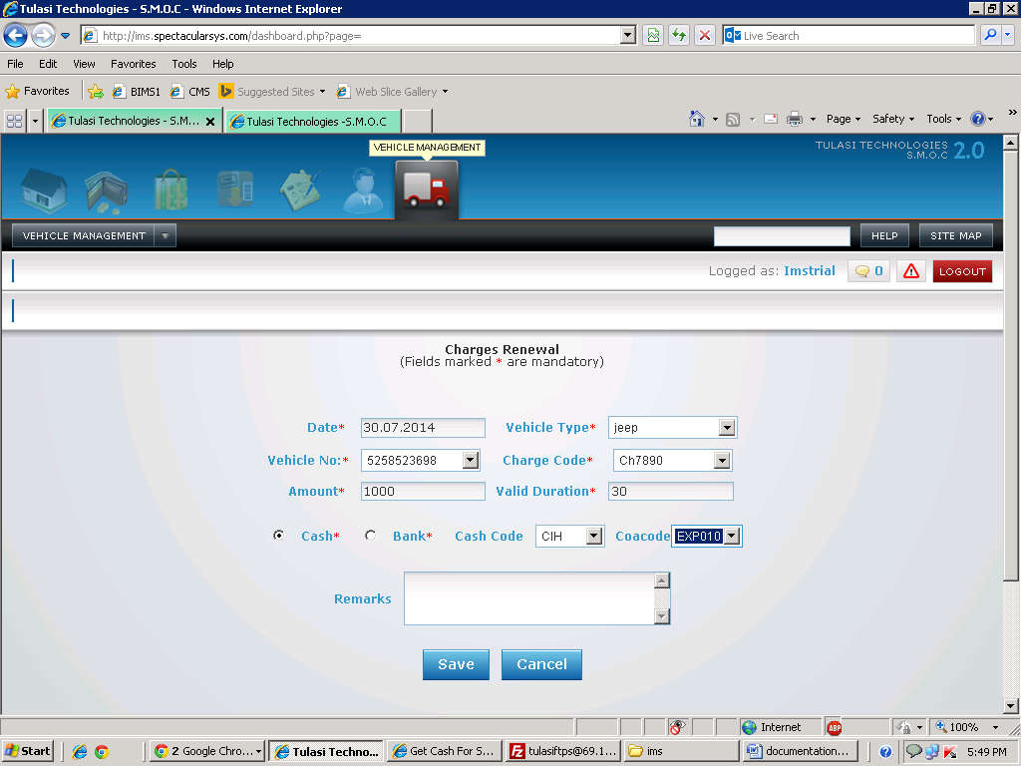

Basic Functionality:

1. This form is used for charges renewal.

2. You need to select vehicle type, vehicle number and drive and charge code

3. After you need to enter details like amount and valid duration

4. After you have to select cash/ bank through which you are paying.

5. Based on selection cash code or bank code will load. You have to select cash code and coacode.

Financial Impact:

|  |  |  |  |  |  |  |  |  |
| --- | --- | --- | --- | --- | --- | --- | --- | --- |
| Item code | Crdr | Coa code | Quantity | Amount | Trnum | Type | Venname | Warehouse |
|  | Cr | AS180 | 20 | 1000 | RW-8 | RW | imstrial | Kolkatta Head Office |
|  | Dr | EXP010 | 20 | 1000 | RW-8 | RW | imstrial | Kolkatta Head Office |

Effecting Tables:

* ac_financialpostings.
* Vehicle_renewal